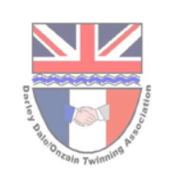**From the Derwent to the Loire**

The monthly newsletter of the Darley Dale/ Onzain Twinning committee

July 2025

Welcome to what we hope will be the first of regular updates relating to our twinning activities. Please let us know what you think about it, and what regular features you would like to see in future. Otherwise, it’s been a busy month since we had our AGM at St Helens in June. The main focus is still very much on trying to engage with young people within our community; and we have had some small successes

.

What’s coming up

* Gig in the Park – Sunday August 24th. Promotional stand – volunteers still needed to help please!
* Official opening of the new Onzain Garden, Whitworth Park, Station Road; Provisionally 4 September @ 11am. All welcome
* Autumn Concert – Darley Dale Brass Band and Fishpond Choir – Saturday 1 November at St Helen’s church (full details to follow)
* Invitations to visit Onzain in May 2026

Celebrating achievements

* Although our AGM on 11 June was only modestly attended we had a lot of very positive discussion.
* We have recently had a very positive meeting with Head Of Languages at Highfields School to discuss various opportunities through Twinning
* Secondary school teacher in Onzain has identified many projects she would like to take forward with students in Darley Dale
* Alfie Flint of Brother Hub (based in Darley Dale) has created some innovative opportunities, which will surely tempt teenagers living in both Darley Dale and Onzain?
* Contact made with Darley Juniors FC (celebrating their 50th season in 2025-26) re-established
* Closer working with Wirksworth Twinning group to share ideas.
* Very helpful discussions with DD town Council community engagement Officer about website design and social media

Opportunities created

* Links with Highfields offering students the chance to undertake Community Service through membership of our Twinning committee
* Opportunity for creative talent at Highfields to assist us with design of new website and our social media

A word from our members

* Please feedback to us about items in this newsletter
* We are actively trying to grow our membership base. Please forward this newsletter to friends and neighbours and ask them to get in touch so we can add their details.
* We are also looking to engage with members of our local business community. We have already identified a number of business opportunities linked to twinning, but no doubt there are more we can talk about?

How to get involved

* We are seeking a computer literate person, with creative talent to redesign and rebuild our website, Facebook pages and newsletter
* Vacant committee positions for anyone with interest in becoming involved. No experience needed. Come along to a few meetings to get a feel for what we are doing, before you decide if it is something you want to be more involved with. Time commitments to suit you.
* We are looking for local businesses who may be able to provide support, or opportunities for our twinning priorities (certainly not just financial!!)
* If you are interested in any of these opportunities, please contact David Gray at [d.gray811@btinternet.com](mailto:d.gray811@btinternet.com).

AGM – 11 June 2025

AGMs are not always the most exciting of events, but the event this year at St Helens created a lot of positive and interesting discussion between those there.

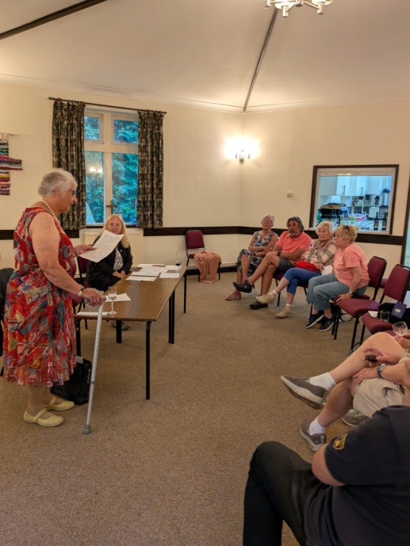

Darley Dale in Bloom’s Chairperson, Christine Goldsack, gave us an update on how the new Onzain flowerbed in Whitworth Park was being extended, and how it would subsequently be one of the centre pieces of the floral display in this year’s judging of gardens. We are eagerly awaiting the judge’s award decisions in September.

We also appointed our committee for 2025.

David Tidd has taken on the role of Chairman with his wife, Linda, supporting him as the vice chair.

Nadine Snowshill and David Gray remain as Secretary and Treasurer respectively.

Other committee members appointed were Bob Hingston, Steve Thomson (Darley Dale band) and Richard Powley (Winster Morris)

David (T) presented a summary of how the committee had already achieved some of its ambitions within the 2025-29 plan, as well as the progress being made on others.

Meet our new committee by reading their pen profiles towards the end of this newsletter below.

Update from the Loire

The Comite de Jumelage in Onzain are being very supportive and enthusiastic of our efforts to implement the 2025-29 plan. They have been very actively helping us to find the contacts to take forward specific initiatives.

David, our Treasurer, paid Onzain an informal 2-day visit in May, at the end of his own holiday to France. He reported back to us on just how warmly he and his wife, Jenny, had been welcomed. On the first evening they not only enjoyed a sumptuous dinner at President Pierre and his wife, Agnes’ house, but they also survived the evening of speaking almost entirely in French! Whilst Agnes has committed to improving her English by using DuoLingo, David has opted to improve his levels of speaking and understanding using Busuu. We’ll follow their progress in the months ahead. David and Jenny were invited to an informal Jumelage meeting the next morning where they met up with other members of the Onzain committee and were totally overwhelmed by their enthusiasm for maintaining strong twinning links with Darley Dale. After a BBQ lunch, and more wonderful hospitality with Eve and Danni, the couple were taken on a tour of the very impressive international designed gardens within the grounds of the nearby Chateau de Chaumont. Both at a personal, and wider committee and community level, our links with Onzain are pretty buoyant.

Possible trips to Onzain in 2026

There are some exciting discussions taking place about a trip to Onzain over the weekend of 14-16 May 2026. A formal invitation has now been made to the Fishpond Choir and Winster Morris team. It is hoped the Fishpond Choir will be part of a 3 way concert that will include choirs from not only Onzain, but also Flein (a town in Germany which is also twinned with Onzain). Early indications from members of the Fishpond Choir suggest a significant amount of interest and much enthusiasm from their musical director. Anyone else from the wider community who may be interested in being part of the visit should contact David Gray ([d.gray811@btinternet.com](mailto:d.gray811@btinternet.com))

New partner organisations

As part of our 2025-29 plan we are looking to get more community organisations involved in twinning activities. Through twinning we can potentially offer all sort of opportunities to their members, not only in the Darley Dale community, but also with our friends in Onzain. Earlier this year both Darley Dale in Bloom and the Fishpond Choir confirmed their intention to work closely with us. More recently we have had contact with Alfie Flint of Brother Hub

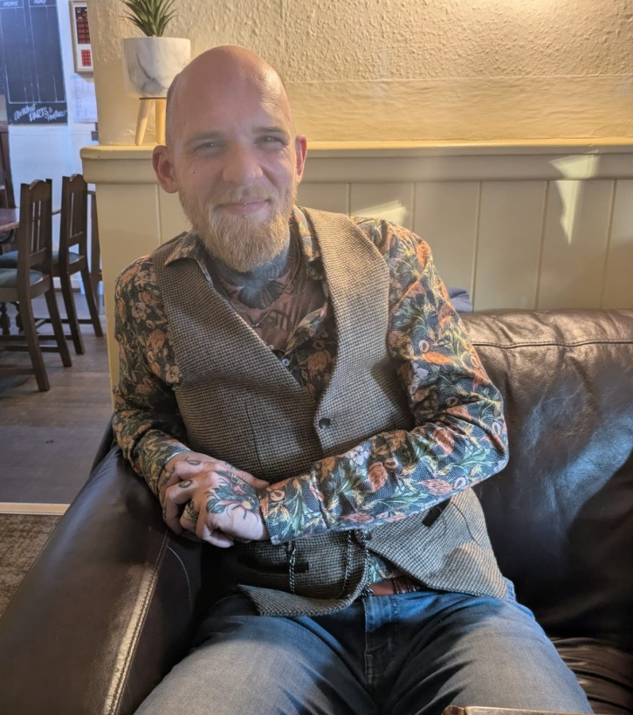

Alfie Flint - Aiming to revolutionize men's mental health and youth support within Darley Dale and the wider area around us

Brother Hub is a groundbreaking initiative aimed at transforming men's mental well-being and fostering resilient communities.

It also offers free, positive experiences for young people. It has launched in Darley Dale, with ambitious plans to expand across the Peak District, and beyond. This project is spearheaded by Alfie Flint, a local visionary whose own battles with learning difficulties and mental health challenges have fuelled a powerful drive to create tangible change.

Alfie has already engaged with some of the youth within Darley Dale by offering a series of cinema nights. Alfie has no previous knowledge of Twinning whatsoever, but within days of meeting with us he has designed the outline of an on-line, interactive challenge; The Twin Town Treasure Challenge. It will provide a collaborative, cross cultural treasure hunt, designed to engage people of all ages in both Darley Dale and Onzain; maybe opening up to even more communities in time!

By the time of our next newsletter we hope this wonderful initiative will have been introduced to, and embraced by some of the youngsters in Darley Dale and Onzain – watch this space!

Our new Twinning Committee

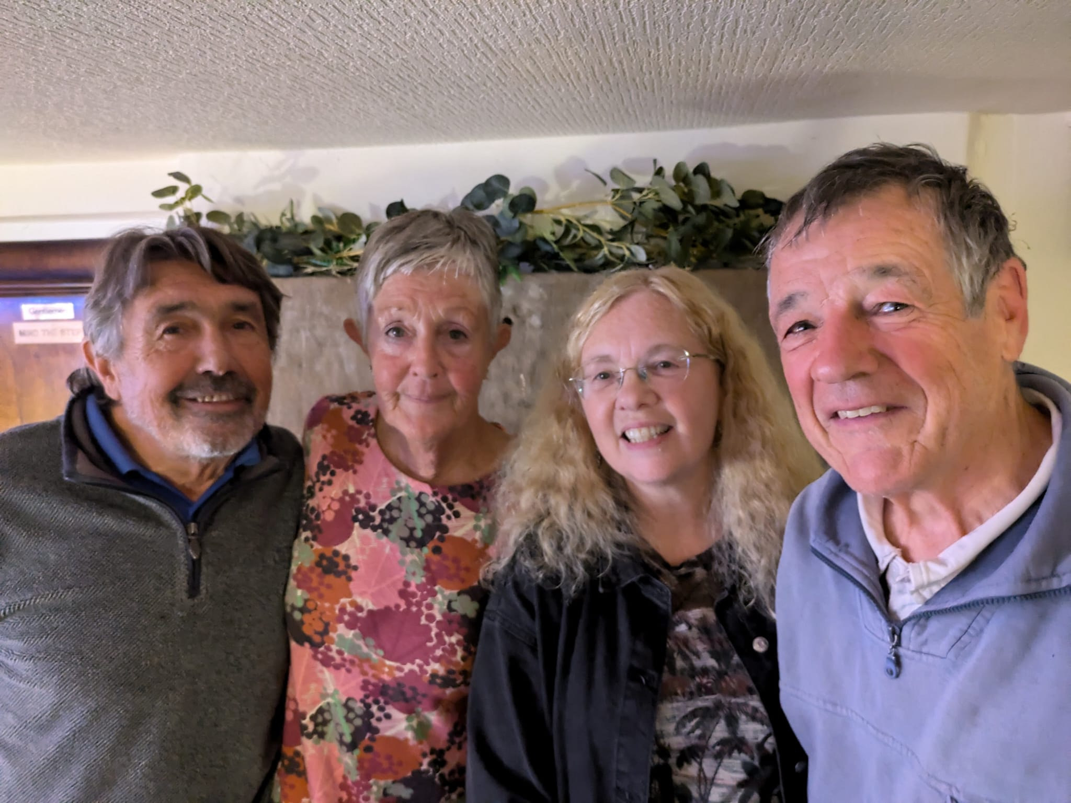

The officers: David T, Linda, Nadine and David G

David (Chair) & Linda Tidd (Deputy -chair) are married and now retired . They have travelled extensively in Asia and have lived in India. 3yrs ago they relocated to England after living in France for

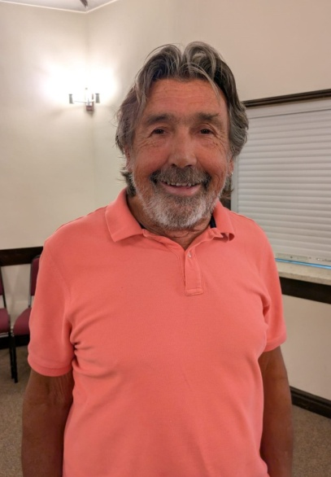 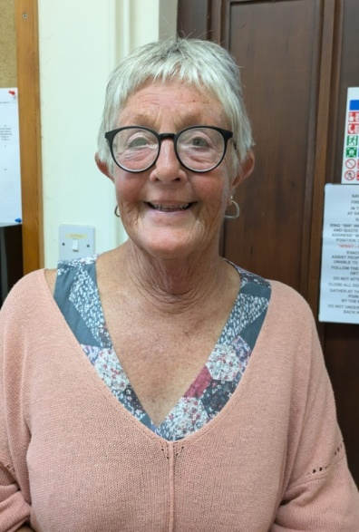

16 years. They are presently enjoying extended trips in their caravan with their two dogs.  
Theirr wonderful time in France spurred them on to join the twinning association, something they feel that is beneficial to both communities.

 Although Nadine was brought up in Birmingham she has lived in Darley Dale for nearly 40 years, and raised her 3 children here. While they were young, she was Chair of Governors at Darley Churchtown Primary School, and was instrumental in establishing the Breakfast and After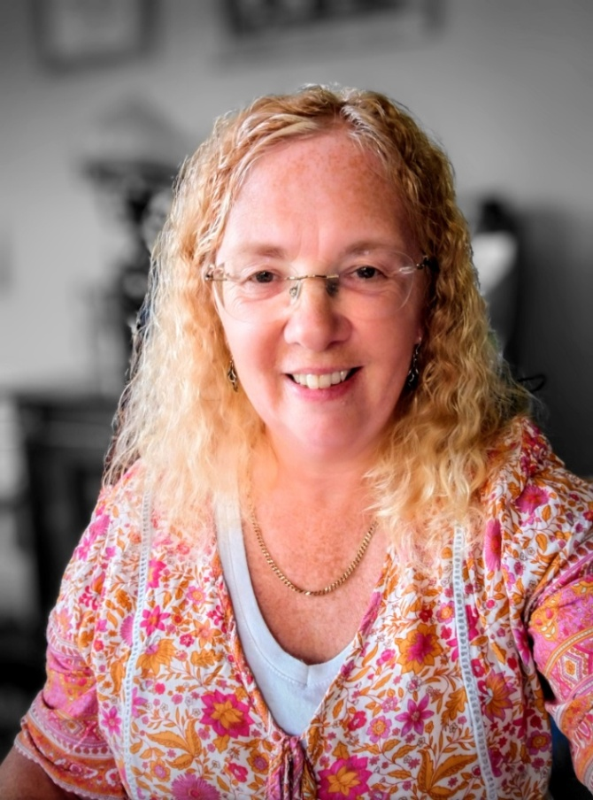 School 1

 Though now retired, she was a General Practice Doctor, specialising in Mental Health and Drugs Misuse, and created a large 5 site surgery that merged with the local hospital in Chesterfield.

 She became involved with Twinning in it's early years, and met Laurence and Sylvain Graton when they were teenagers! Though they lost contact with Twinning during her busy working life, she never lost contact with their friends in Onzain, and is delighted to be reunited with them, with Onzain, and with Twinning once again.

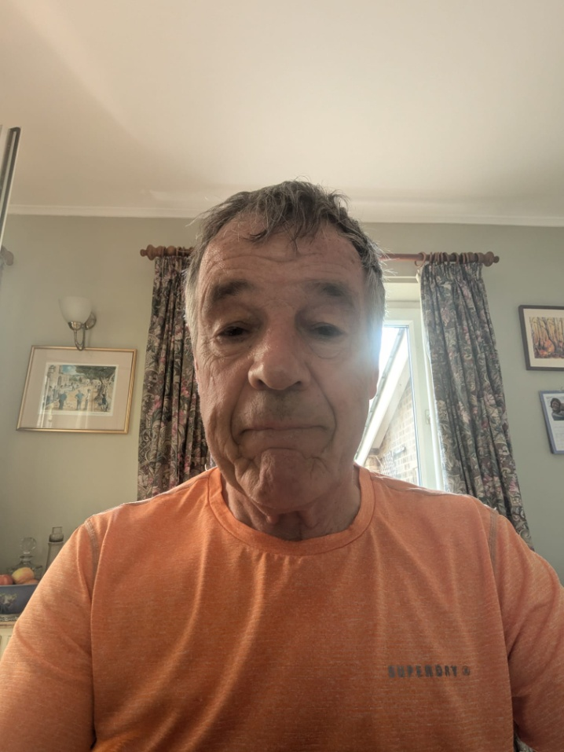

David grew up in Matlock before leaving the area to study in Newcastle and then Nottingham as an accountant. Work gave him, and his wife Jenny, the chance to live in Auckland, New Zealand for 3 years before returning to the UK with a young family. A complete coincidence gave them the chance to take up a “dream” job, back in the heart of the Peak District, in Bakewell.

A full circle around the world bought David back to the area he knew so well. After 40 years in Bakewell they looked for a quieter place to live, and feel extremely lucky to have found a suitable house in Darley Dale; just half way between Matlock and Bakewell.

With no previous experience of “twinning”, but an inbuilt suspicion of big committees, it was with some trepidation he agreed to take on the role of treasurer. David is retired, has 2 children and 3 grand-children, none of whom live nearby. He played rugby to a level far beyond his natural ability until he was in his mid-40s, and still tries to keep active through lots of cycling and by running 2 half marathons a year.

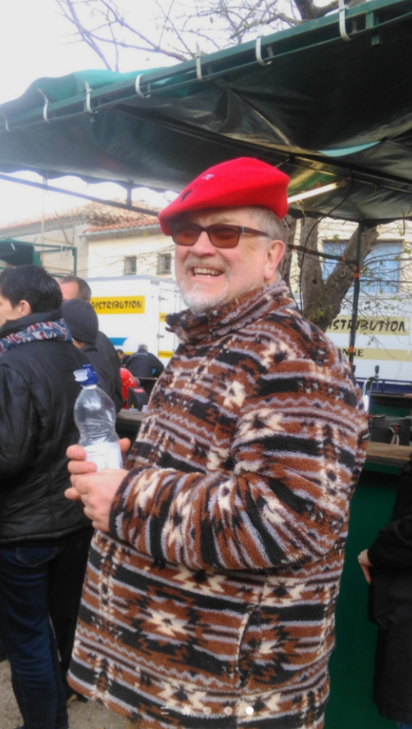

Bob retired and has spent a great deal of time in the south of France, over the last 30 years.

This picture was taken in Azille, where he owned a house with his wife, at the time of the Feria in early May 2014.

A few years ago, he became involved with the twinning association and has had visitors staying with us, both here in Darley Bridge as well as visiting them in Onzain.

They downsized, so are unable to host families at the moment, however, they believe wholeheartedly in the association.

Whilst in Onzain, Bob was overcome by the welcoming nature of the town and its residents, who were so welcoming; in fact they even allowed him to sing in their choir!!

Any feedback on this newsletter, or queries relating to the work of the Darley Dale Twinning Group should be sent to D.gray811@btinternet.com