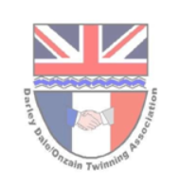
From the Derwent to the Loire

The monthly newsletter of the Darley Dale/ Onzain Twinning committee
September 2025

As we come to the end of what has now been confirmed as the warmest UK summer on record, we can reflect on another couple of very busy months for the Twinning committee. Progress against steps within our 2025 Plan sometimes seems to be frustrating, and a bit slow at times but, notwithstanding that, we all feel as though there are many more positives than disappointments.

Keep the date free

- Wirksworth Wizarding weekend – Sunday 5 October with a twinning Quizadry event in the afternoon.
- French language café – 8 October @2pm (venue to confirm)
- Autumn Concert – Darley Dale Brass Band and Fishpond Choir – Saturday 1 November at St Helen’s church (full details to follow)
- Visits to Onzain by The Fishpond Choir and Winster Morris in May 2026

Celebrating achievements
- Feedback on our first newsletter was generally favourable and supportive. We will be trying to improve it every time so please do feedback with your thoughts and ideas. We are trialling a new feature this month that will take individuals and businesses from within Darley Dale who are making contributions to the community. We hope this is interesting to both our readers in Darley Dale, as well as those looking in on us from the Loire.
- The twinning group enjoyed being at Darley Dale’s Gig in the Park event on 24 August. We had a good level of visitors to our tent where various activities kept everyone amused.
- One of our visitors to the event turned out to be a wine maker who has offered to look at the possibility of using the grapes from Darley Dale’s 3 vines (currently growing at Amber Valley Vinyards, near to Wessington) and making them into a case of unique Darley Dale wine.
- The Onzain garden opening ceremony was certainly no damp squib, despite some heavy showers! It was a huge success and a joint celebration of our group’s founder’s 95th birthday. Read more further down).
- Although the schools here have been on holiday over the summer we have had confirmation from France that schools in the Onzain area are very keen to develop links with school kids and teachers here. We will be following up on the links we made before the end of last term at Highfields, Lady Manners, Darley Churchtown and Darley Primary.
- We’ve had our 3rd meeting of the French language café and are now ready to open it up to a wider group. We will be limited on numbers, so invitations will be on a first come basis.
- We continue to work with Alfie Flint of Brother Hub (based in Darley Dale) to develop an interactive Treasure Quest challenge
- After making promising contact with Darley Juniors FC (celebrating their 50th season in 2025-26) we have had no response to the request that the club re-engages in active twinning events. We will continue to look at ways this could be facilitated.
- We are continuing to improve contact with the Wirksworth Twinning group to share ideas.
- Through our attendance at the Gig in the Park event we have had a response to our request for someone to help us redesign our website and social media sites. We will be meeting to discuss this in the weeks ahead.

Opportunities created
- Despite all the activity and achievements no specific opportunities created this month

A word from members of the community
- Our committee is under pressure to expand the range of activities it can take forward. We need more people from within the community to be involved, for however little time they can spare. If you, or someone you know might be interested then please do get in touch with us
- We are actively trying to grow our membership base. Please forward this newsletter to friends and neighbours and ask them to get in touch with Nadine nadine.snowsill@gmail.com so we can add their details to our data base. There is no commitment by signing up and you can always ask to leave at any time!
- We are also looking to engage with members of our local business community. We have already identified a number of business opportunities linked to twinning, but no doubt there are more we can talk about?
- We are starting a new section within the Newsletter this month whereby we go out to meet people who live, work or play in the community. This month we’ll introduce you to Jordan Walton, General Manager at Joni and Jerry Smith who won this year’s Darley Dale in Bloom hanging basket competition. It may be you that we visit next month!

How to get involved

- Vacant committee positions exist for anyone with interest in becoming involved. No experience needed. Why not come along to a few meetings to get a feel for what we are doing, before you decide if it is something you want to be more involved with. Time commitments to suit you.
- We are looking for local businesses who may be able to provide support, or opportunities for our twinning priorities (certainly not just financial!!)
- If you are interested in any of these opportunities, please contact David Gray at d.gray811@btinternet.com or our Secretary, Nadine at Nadine.snowsill@gmail.com .

Update from the Loire
The Comite de Jumelage in Onzain continue to be very supportive and enthusiastic of our efforts to implement the 2025-29 plan. They have been very active in helping us to find the contacts to take forward specific initiatives.

We had hoped to find a French website which featured activities taking place in Onzain each month, but alas no such resource appears to exist. The Comite de Jumealge do not have their own website, and nor is there anything which gives an impression of what the town and countryside around it looks like. We will continue to explore ways to give residents of Darley Dale an easy way of familiarising themselves with the town and the people who live in our twinned town on the Loire.

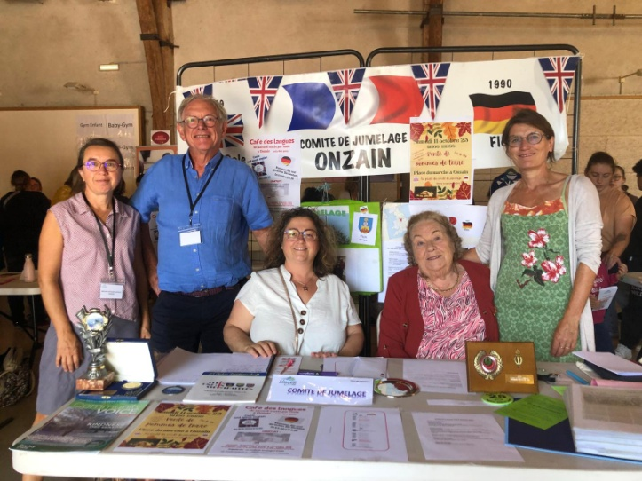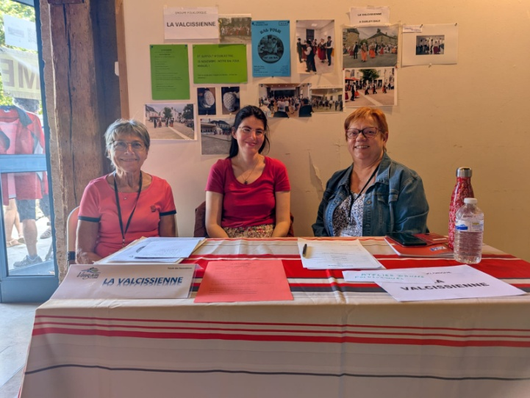
Onzain Jumelage and La Valicissienne members at this year’s Forum des Associations. An annual chance for all organisations in Onzain and the surrounding area to promote the activities they offer to the local community.

Trips to Onzain in 2026

There are some exciting discussions taking place about a trip to Onzain over the weekend of 14-16 May 2026. A formal invitation has now been made to the Fishpond Choir and Winster Morris team. It is hoped the Fishpond Choir will be part of a 3 way concert that will include choirs from not only Onzain, but also Flein (a town in Germany, which is also twinned with Onzain). Early indications from members of the Fishpond Choir suggest a significant amount of interest and much enthusiasm from their musical director. Winster Morris may look to share the bus to get there. Anyone else from the wider community who may be interested in being part of the visit should contact David Gray (d.gray811@btinternet.com)

Twin Town Treasure Quest Challenge

In our last newsletter we announced that our newest partner in Darley Dale, Alfie Flint, had designed the outline of a new on-line, interactive challenge; The Twin Town Treasure Challenge. We still hope it will eventually provide a collaborative, cross cultural treasure hunt, designed to engage people of all ages (especially younger age groups) in both Darley Dale and Onzain; maybe opening up to even more communities in time! We are still working on a “pilot” of the challenge and testing that all of the chosen computer platforms work properly, and safely, to protect everyone using it. We’ll keep you updated on its development but it is still an exciting prospect.

Wirksworth Twinning Group

We are starting to liaise more closely with the Wirksworth Twinning Group, especially as they have lots of great ideas about how to increase the profile of “twinning” within their community. Instead of having just one link, they have “twinned” towns in France, Germany and Italy. Sunday 5th October is Wirksworth Wizarding Day. As part of the wider events taking place throughout the day, “twinning” is holding a wizarding quiz fundraising event at the gothic hall (the old Baptist Church on Coldwell Street). The event is called: Quizardry at the Gothic Hall and there will be two separate quiz events: at 2pm and 3.30pm. It should be a magical afternoon, please try and get over to support them.
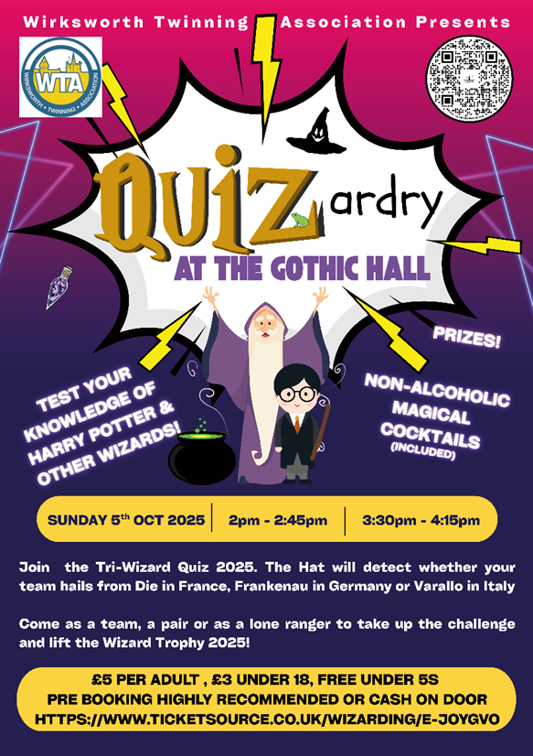

If you would like to attend the event, here’s the link to buy tickets:
https://www.ticketsource.co.uk/wizarding/quizardry-at-the-gothic-hall/e-joygvo Or you can use the QR code on the top of the poster.

Wirksworth Twinning group also promote a programme of foreign sub-titled films at the Northern Light cinema. It is a lovely, traditional cinema, which offers a wonderful environment in which to watch films.Their next Twinning film will be From Hilde, With Love, in German with English subtitles. Book tickets on the Northern Light cinema website: www.tnlcinema.co.uk

Showings are:
8.00pm, Monday 29th September (with twinning nibbles from 7:30pm)
5.30pm, Tuesday 30th

Gig in the Park
I’d love to be able to say we were inundated with visitors to our gazebo at the Gig in the Park, all desperate to learn about “twinning” and how they could get involved with it, but……….. The afternoon was lucky to have the perfect summer afternoon weather for the event and Whitworth Park was full of families picknicking, and enjoying the sunshine whilst they listened to local bands. We were pleased to have been invited to be a part of the event and those people who did come over for a chat seemed very interested in what we were doing.

The activities we had set up for younger members of the community proved very successful. Darley Dale Community radio’s host DJ, Tom Peet set a blistering opening time ( I minute 21 seconds) for the challenge to complete the jigsaw map of Europe. Others who followed him found that it was not quite as easy as they thought to locate and position all European countries the right way up, and in the right place. Whilst many tried the challenge, we had one persistent visitor who was determined to beat Tom’s impressive time. Having eventually beaten it with an incredible time of 1 minute and 6 seconds, Ollie bought his mum over to be the timekeeper, and then recorded a miraculous time of 1 minute and 5 seconds. Unfortunately we had no prize for him! But a lot of fun.
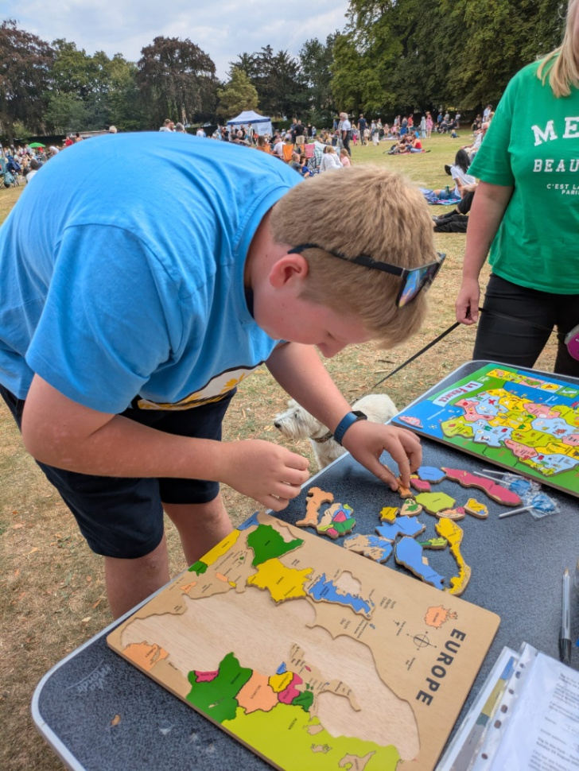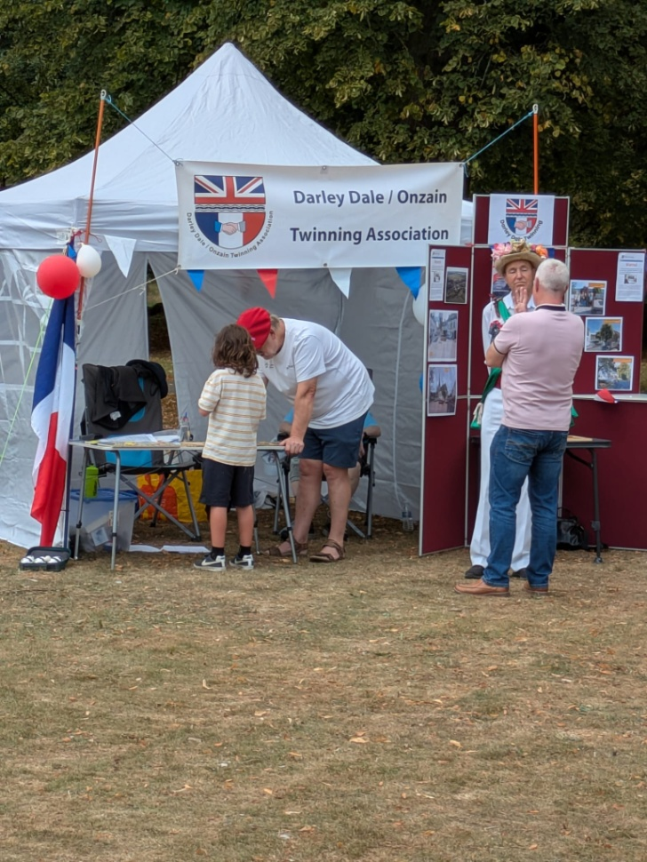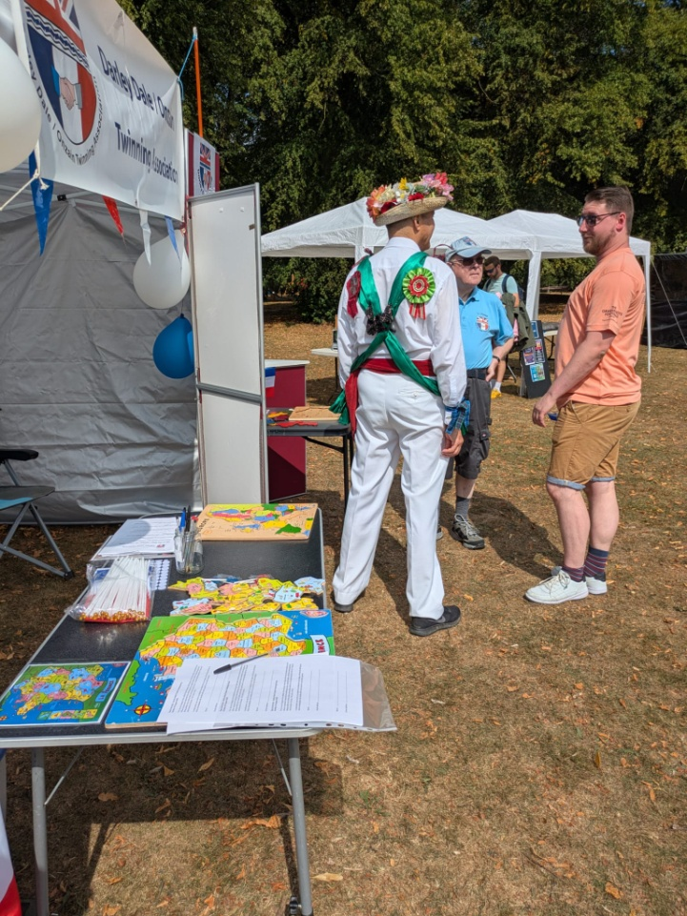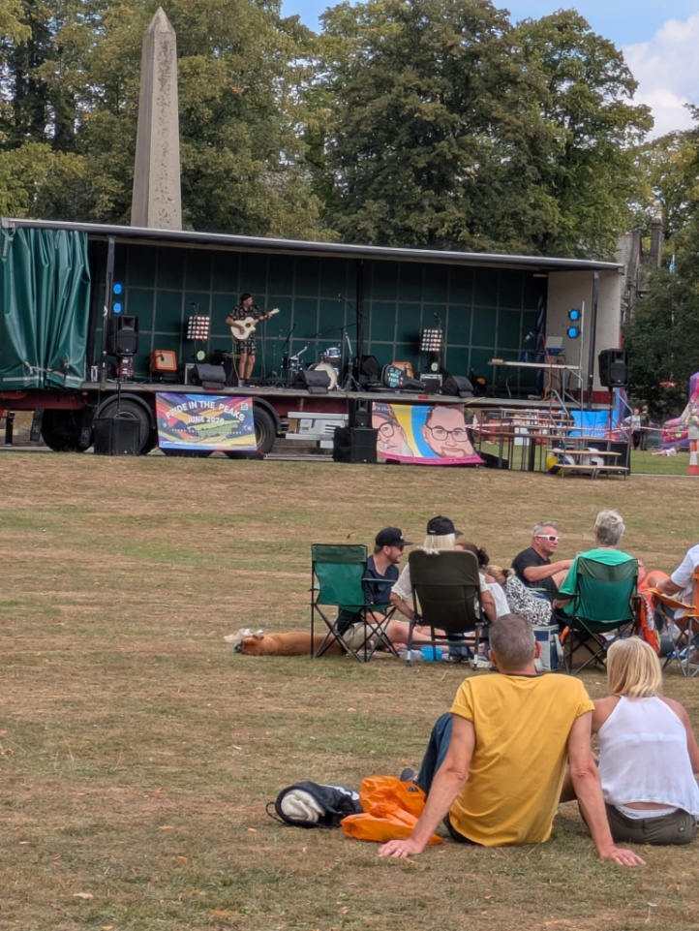

(In)formal opening of the Onzain flower garden

The new flowerbed at the entrance to Whitworth Park, off Station Road was kindly sponsored by Christine and Alan Goldsack and planted up by members of Darley Dale in Bloom. It was formally dedicated to the town of Onzain at a lovely ceremony on 4 September 2025.

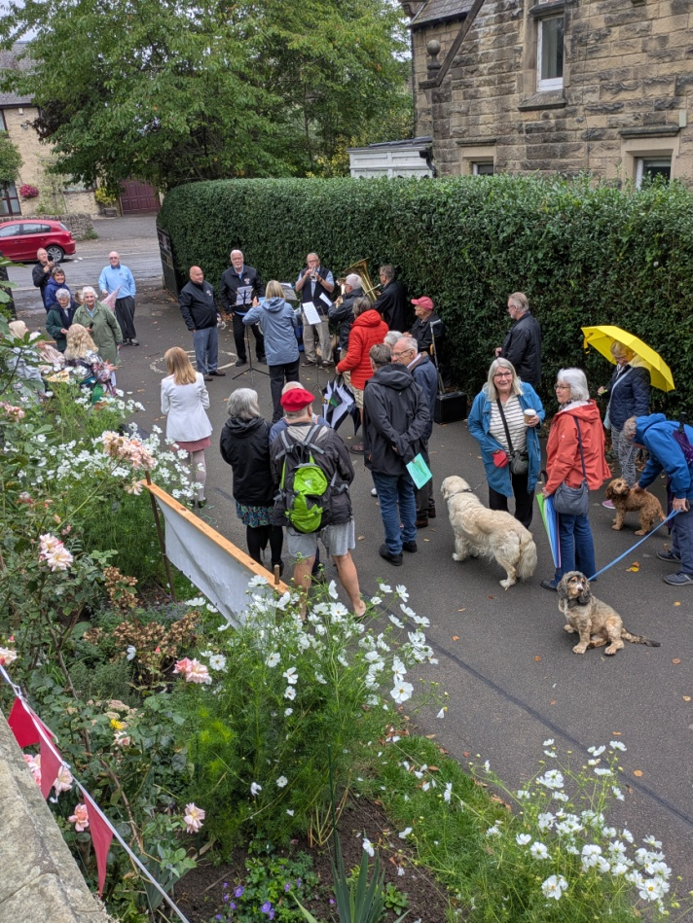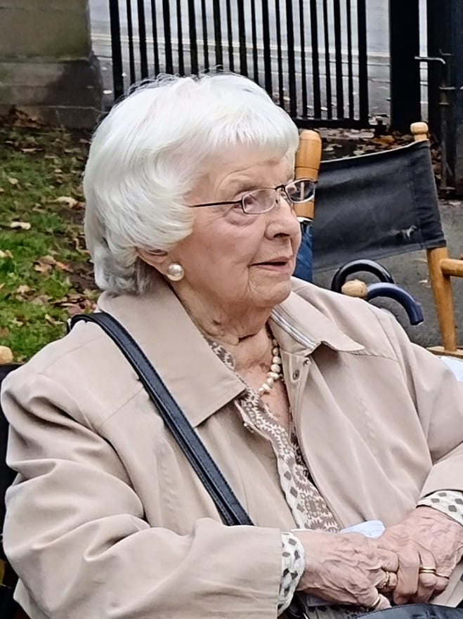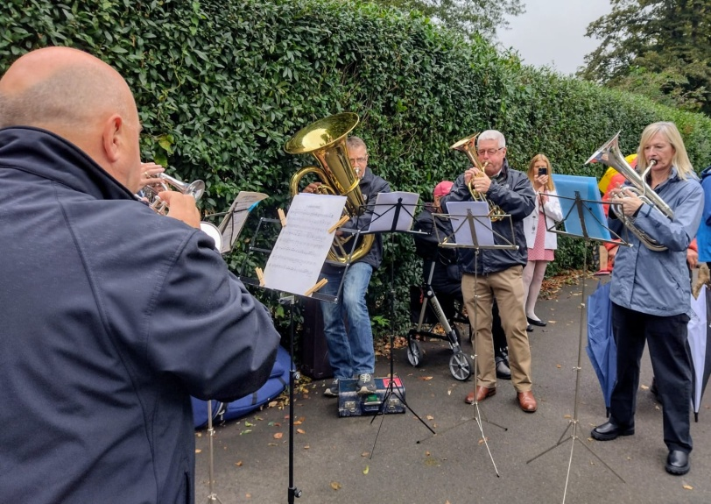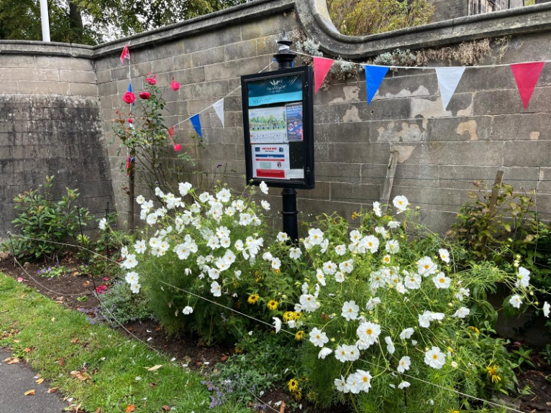

The showers mostly held off, allowing members of the Darley Dale band to play a medley of suitably jolly songs, a rendition of “Happy (95th) Birthday” to Shirley Davidson (the person responsible for setting up the twinning movement in Darley Dale in 1989) and the Marseillaise, whilst Shirley cut the ribbon to complete the dedication. Long may the garden prosper and bloom.

Just before the heavens opened with the most incredible downpour, we all moved into the Terrace café for celebratory “tea and cake” to round off the most English of English experiences.

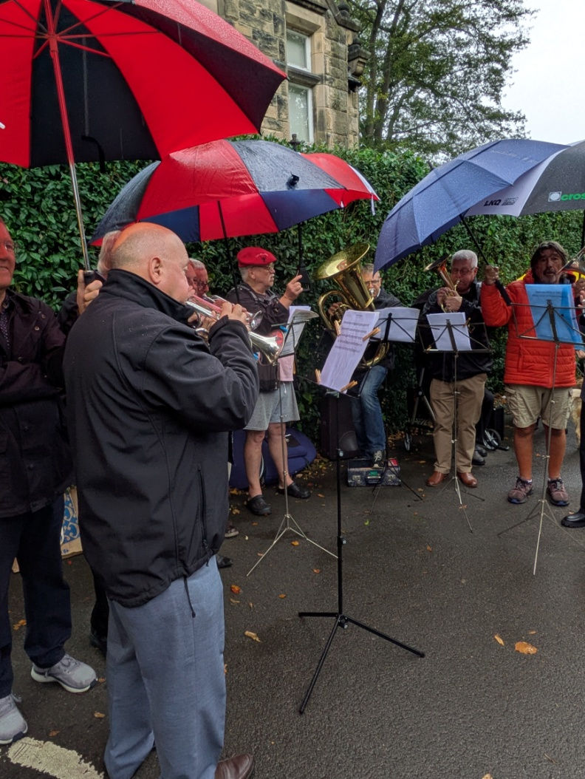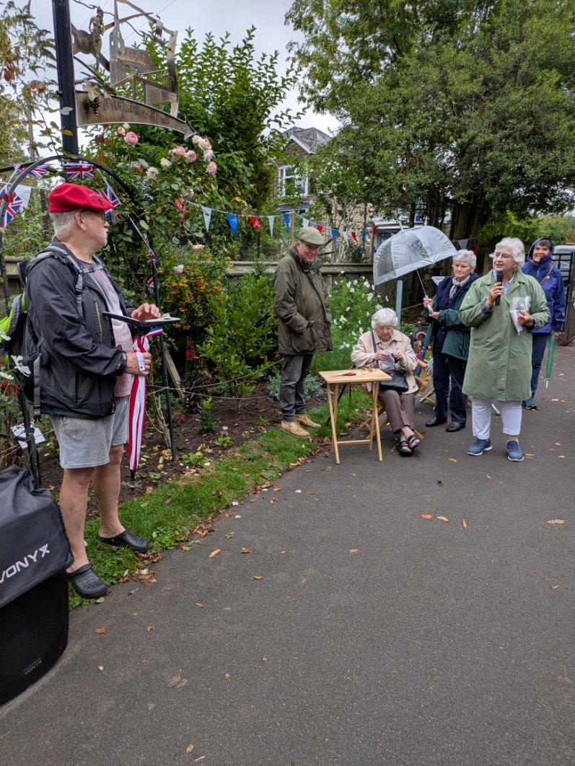

People in our community

This is a new feature in the newsletter in which we will reveal each month some of the people who live, work and relax in Darley Dale. This month we are featuring the winner of the Darley Dale in Bloom hanging basket competition, Jerry Smith, and Jordan Walton, manager of Joni.

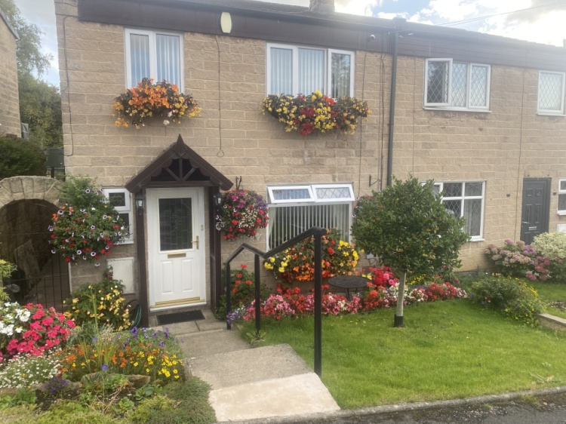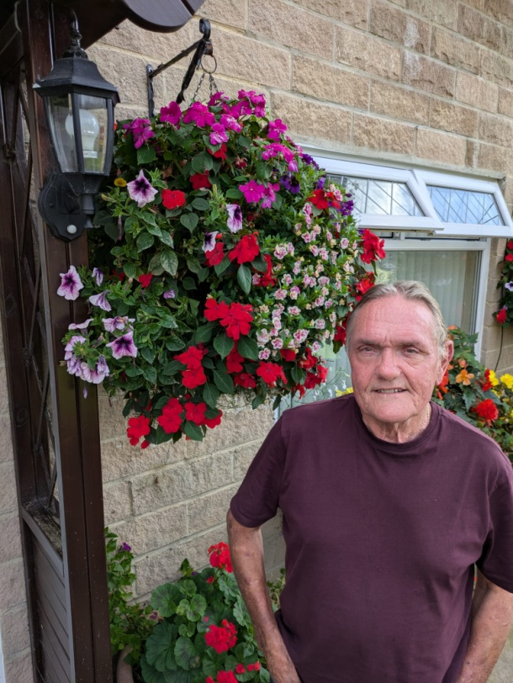

Jerry Smith grew up in a family of gardeners and believes he might even be related to the “Smiths” who set up as nurserymen in the local area. His mother was a keen grower of flowers in Matlock Bath as he was growing up, but it’s only in the last 28 years that this has become such a passion for Jerry.

This has been the 3rd year that Darley Dale in Bloom has run its hanging baskets and planters competitions, but only the first time Jerry had entered. He hadn’t seen the local advertising for the event and so didn’t enter until his wife, Glenis, encouraged him to respond to an invitation that was pushed through their letter box. There were 15 entries this year in the hanging basket competition. Although Jerry produces a wonderful display of begonias for his window boxes and hanging baskets every year, he never for one moment thought he would win the competition. As it is, he and Glenis will be proudly attending the DDiB presentation ceremony on 10 October (Darley Dale Methodist Hall) to collect his award.

Jerry’s health this year has not always been good, and the daily task of watering his plants, front and back, requires an hour of hard physical effort in both the morning, and each evening. Still, it is all very worth it as the tendering and nurturing of such a big display brings him so much pleasure and mental satisfaction. “Neighbours and other people walking along the street stop and stand to stare at the display” he told me “ It makes me feel a real sense of achievement in making our part of the community a brighter place…..”.

With this year’s success behind him he has adventurous plans to create spherical flower balls next year, especially if he can get his new greenhouse built and start to grow his own plants from seed. Look out Darley Dale, Jerry has clear ambition to hang on to his title in 2026!
For the first of our insights to businesses in Darley Dale we went along to meet Jordan Walton who is the manager of Joni, situated just off the A6, opposite to the Co-op. There are of course several other cafes and tea rooms within our community and we will be visiting these in the months ahead.
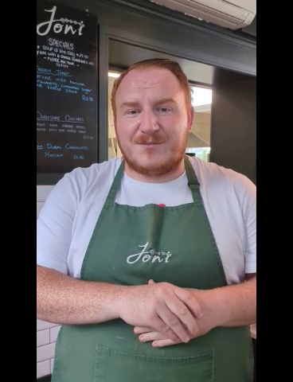
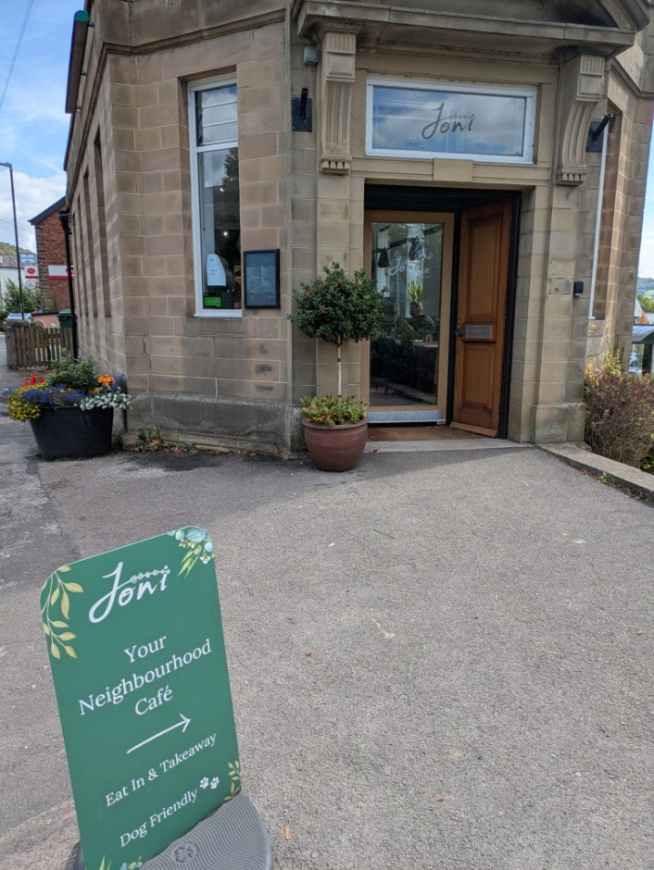
We are unable to embed a link to the video within the newsletter, but Jordan from Joni’s is pictured above. To watch the video showing our meeting, please go to our Facebook page or follow the link to our website: https://www.darleydaletwinning.org.uk

Although Jordan doesn’t live in Darley Dale he enjoys working here and is getting to know the customers who live in the town. He has 10 years experience of working in the hospitality industry across the East Midlands and after my visit I think he may have some plans to consider introducing a few French pastries. So, if any of our French readers can provide some recipes then please do send them in!

Any feedback on this newsletter, or queries relating to the work of the Darley Dale Twinning Group should be sent to D.gray811@btinternet.com

