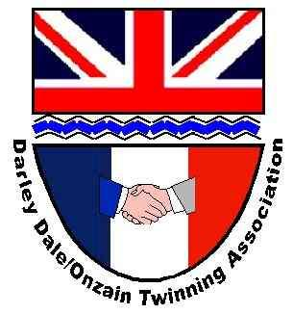
From the Derwent to the Loire
The newsletter of the Darley Dale/ Onzain Twinning committee
January 2026

Happy New Year for 2026 Meilleurs Voeux pour 2026!

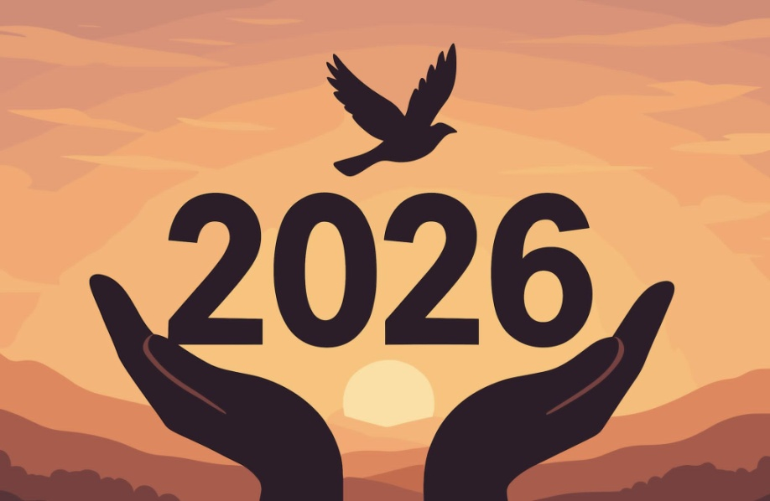

:
Je vous souhaite
Du travail et de l’argent pour vivre agréablement
Une santé robuste
Des joies simples et des moments de douceur
De belles surprises
C’est parti pour une Très Belle Année 2026

This is one of the many very special messages we have received from the Jumelage committee in Onzain. We wish every one of you, and those you love a very happy and fulfilling 2026.

Dates for your Diary

- French language café –now arranged for first Wednesday of every month @2pm at Square and Compass
- Grand Prize Draw – 14 February 2026 FOR TICKETS to win a dozen quality wines contact David Tidd at davidtidd55@gmail.com
- Visits to Onzain by The Fishpond Choir and Winster Morris 14-17 May 2026
- Wirksworth foreign film – “Dying” at Northern Light Cinema 17 February at 6.00pm or 13 January at 5:30pm. A German film with English sub-titles.
- AGM – 25 June 2026 at 7:00pm (venue to be confirmed.)

Celebrating achievements
- This is our third newsletter and we hope you are enjoying the more regular updates on what we are doing.
- In the last newsletter, we introduced a new feature focussing on individuals and businesses in Darley Dale who contribute to the community. We hope this is interesting to both our readers in Darley Dale, as well as those looking at us from the Loire. If you would like us to feature your business, contact David Gray at d.gray811@btinternet.com
- We have had positive engagement from primary school teachers in Onzain who we are connecting to Darley Churchtown and South Darley primary schools.
- We have now met with teachers from both Lady Manners and Highfield schools. They are considering a variety of options with regards to engagement in “twinning” objectives.
- A secondary school teacher in Onzain requested volunteers for the completion of a festive questionnaire. Many of you hopefully sent your replies back to Catherine and we will let you know the results of her pupils’ analysis, once we receive it.
- On 1 November we supported a concert featuring the Darley Dale Brass Band and the Fishpond Choir, in St Helen’s Church. It was an amazing success, and plans are already being made to repeat this again next year. More details below.
- Our language café has adopted it’s regular home at the Square and Compass. We will be chatting in French at 2.00pm on the first Wednesday of every month (next meeting February 4th) and everyone is welcome. Numbers have fluctuated but hopefully this is one of your New Year Resolutions, and we will see you soon.
- We have reactivated links with one of the Care Homes within our community. The manager at Valley Lodge, Rebecca Stevenson, is considering a number of initiatives. We will work with her, and the staff there, to progress during this year. Creating links with other care homes will be a priority for 2026.
- We have negotiated a 10% discount with Brittany Ferries for Twinning members to benefit from. Please let me know if you would like more details.
- Just before Christmas we held our first WhatsApp video meeting with members of the Onzain Jumelage Comite. As we hold more of these calls during 2026 we anticipate improved communication between our twinned towns, and new ideas to emerge.

Opportunities
- We continue to work with Alfie Flint of Brother Hub (based in Darley Dale) to develop an interactive Treasure Quest challenge.
- We are still looking for help to revamp our website and social media platforms. If you could help, please get in touch.
- We would welcome more people from our community to be involved, for however little time you can spare. Anything from IT to gardening. If you, or someone you know might be interested then please do get in touch.
- We are always growing our membership base. Please forward this newsletter to friends and neighbours and ask them to get in touch with Nadine nadinesnowsill@gmail.com so we can add their details to our data base. There is no commitment by signing up, and you can always ask to leave at any time!
- In our Newsletter section about people who live, work or play in our community we are including 2 more in this issue. This month we’ll introduce you to Rebecca Stephenson, General Manager at Valley Lodge Care home and Sara Rivett, our Community Engagement Officer. Would you like us to visit you next month? Please get in touch.

Valentine’s Day Prize Draw

In order to try and boost our funds to support specific projects and initiatives in 2026, we are running a 200 ticket prize draw. There will be just one winner who will receive a case of premium, mixed wines with a value of around £150. The winning ticket number will be drawn on Saturday 14 February 2026 by his worship the Town Mayor of Darley Dale, Counsellor Jason Farmer at 13:00 hours in the Whitworth café. For your chance to win this valuable prize, tickets can be purchased at Joni’s Cafe, The Whitworth Cafe and The Square and Compass Pub;
or email David Tidd; davidtidd55@gmail.com
Help us to meet our modest running costs and build our reserves to support future twinning initiatives by purchasing prize draw tickets, and perhaps you will be the lucky winner.

Update from the Loire

In early December the Comite de Jumelage held their AGM. They presented a lot of very positive messages and much enthusiasm to enhance their twinning relationships with us during 2026.

We were sorry to hear that Mary-Linn Verdebout has stepped down as a member of the Jumelage Comite and that Pierre Bonneville will no longer be President of the committee after 17 successful years at the helm. I know that everyone connected with Twinning in Darley Dale will be sad to hear these announcements as they have been fantastic contributors to the success of our liaison for so long. At the same time we are delighted to hear that Valerie LHuillier will be taking over from Pierre as President. Valerie has already become a strong communicator with our small committee in Darley Dale over recent months and of course we wish her, and the new committee every success with the future Julelage in Onzain.

It was also interesting to read that the Comite had some discussions about how to attract greater interest in Jumelage from more families and organisations within the Onzain area. We are having similar discussions and initiatives. Hopefully, the enthusiasm we have here in Darley Dale, which is equally matched by that of the Comite in Onzain, will bring more successes for us all in 2026.

Roulons avec les flames project

The French Jumelage Comite are starting a project in which groups of young adults from Onzain, Flein and Darley Dale meet up in Germany over a 4 day period in August 2026. In addition, the project is expected to include a separate adventure to travel by bike for at least part of the journey to the event. European funding is being sought to help with the logistics, but we will be required to contribute to this, as appropriate. We have approached schools and youth groups with the project outline, but this is an exciting opportunity and we’d be very happy to share details of it with anyone who knows of young people who might be interested.

Trip to Onzain in 2026

Arrangements are being made for a trip to Onzain for the weekend of 14-16 May 2026. The Fishpond Choir have been specifically invited to be part of a 3 way concert that will include choirs from Onzain, Darley Dale, and also Flein (a town in Germany, which is also twinned with Onzain). Members of the Fishpond Choir are showing a significant amount of interest, matched by much enthusiasm from their musical director. Winster Morris will enjoy their own invitation from the La Valiscienne dance group to be in Onzain over the same weekend. Both groups will look to share the bus to get to Onzain but, the initial research suggests the recent changes to entry systems into mainland Europe might make the process more complex (expensive!). Planning continues. Anyone else from the wider community who may be interested in being part of the visit should contact David Gray (d.gray811@btinternet.com) but given the numbers already invited, the inclusion of further travellers may depend upon the availability of homes in Onzain to accommodate us all.

Autumn concert at St Helen’s church

The Concert featuring both Darley Dale Brass Band and The Fishpond Choir at St Helen’s Church, Darley Dale seems to have been a great success. Everyone involved in organising, performing or watching the performance hailed it as a wonderful evening, and one we should look to repeat next year. No one can remember these two well established, local groups performing together before, but it made for a marvellous community event with an eclectic range of musical pieces. Everyone joining in to sing Jerusalem at the end created a grand finale to a memorable evening. The event, together with a very successful raffle, also bought some much needed funds into our coffers as we look to rebuild our reserves to fund 2026 projects.
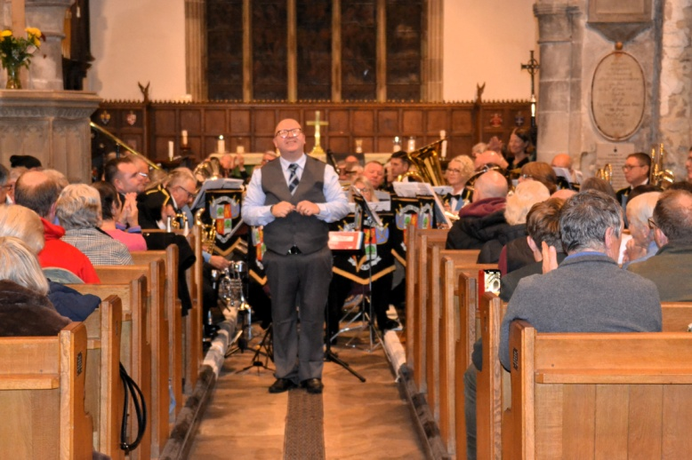

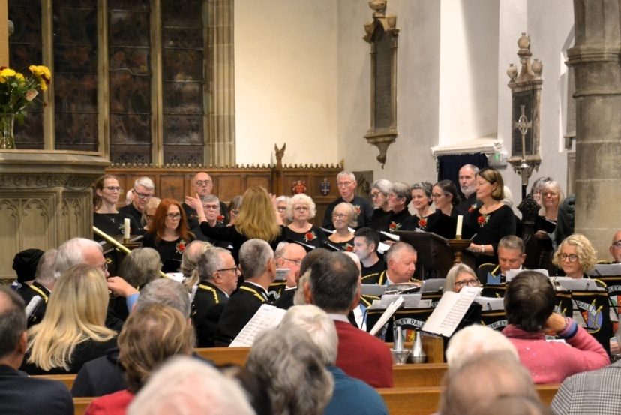

Ferry discount agreement

We have recently managed to arrange a discount for members travelling with Brittany Ferries. Whilst special promotions and offers may be more preferable than the 10% discount we have been offered, the arrangement may still benefit some people. The arrangement applies to “members” of a Twinning organisation, so anyone wishing to take advantage of this disccount should contact David Gray at d.gray811@btinternet.com

Unfortunately Le Shuttle and Eurostar are not offering the same sort of discounts to Twinning organisations, and we are still pursuing a similar arrangement with DFDS.

Meet the People in Our Community

This was a new feature in the last newsletter. We are focussing on some of the people who live, work and relax in Darley Dale by using a short video interview with them. This month we are featuring Rebecca Stephenson, Manager of Valley Lodge Care Home and the two Sara(h)s who run front line community engagement roles, based in the Whitworth.
We are unable to actually embed a link to the videos within the newsletter, therefore, to watch the videos featuring our recent meetings with Rebecca, Sara and Sarah, please follow the links on our website.

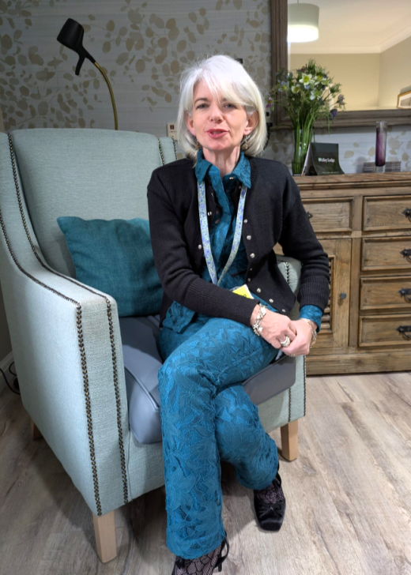

Rebecca Stevenson manages a staff of over 100 people and 60 residential patients at the Valley Lodge Nursing home, situated along the A6 at almost the most southerly extreme of Darley Dale. It is always a busy place but Rebecca is very keen to engage with a wide range of people within the community to help bring the best quality of care and therapy to those working at, or resident at Valley Lodge.

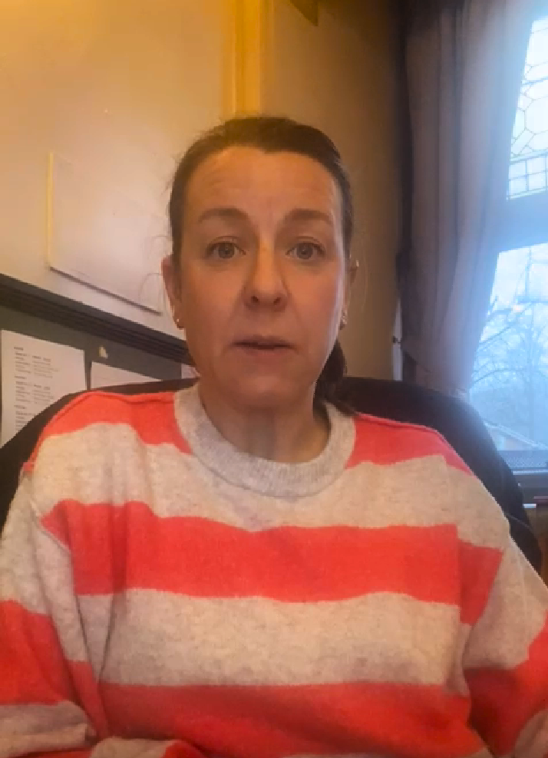
We are also featuring Sara Rivett is the Community Engagement Officer
at Darley Dale Town Council
https://darleydale.gov.uk/meet-your-councillors/

In our next newsletter we will be talking to Sarah Elliott, the Events and Community manager at the Whitworth Trusthttps://www.thewhitworth.org/about-us.

Sara Rivett and Sarah Elliott are each based in busy, separate offices at the Whitworth Institute with people popping in all the time to talk about community matters. Follow the links to get more details about who they are and how they make Darley Dale a better place for us all to live in.

Wirksworth Twinning Group – Foreign films
Some of you are interested in watching good quality foreign films and so we are helping to promote the programme that our friends in the Wirksworth Twinning Group are showing at the Northern Lights cinema in Wirksworth each month.

Their next film is a German film with English sub-titles call “Dying”. It will be showing at 6:00pm on Tuesday 17 February 2026. The Twinning group provide pre-film nibbles from about 5:30 onwards, for those who want to meet beforehand. The film in March will be Spanish.
And finally, with sadness….
Frank & Phyllis Mason have been long term members of Twinning, from almost its inception. They visited Onzain & hosted families at their home during almost all visits in the 90’s, 00’s and 10‘s. For the last few years Frank has been a victim of dementia & Phylis has been crippled with bad hips. Frank died peacefully on Sunday 18 January. Mary, their daughter, and Frank‘s successor as the Winster Witch, would like her blog to be circulated for all those who knew her father to read https://maryrushreflexology.com/2026/01/18/three-years-at-meadow-view-watching-my-dad-change/ . We extend our sympathies to Mary and the rest of the family on their sad loss.

Any feedback on this newsletter, or queries relating to the work of the Darley Dale Twinning Group may be sent to D.gray811@btinternet.com

