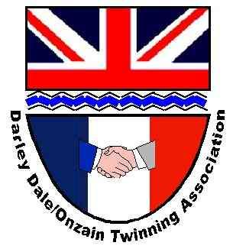
From the Derwent to the Loire
The newsletter of the Darley Dale/ Onzain Twinning committee
May 2026

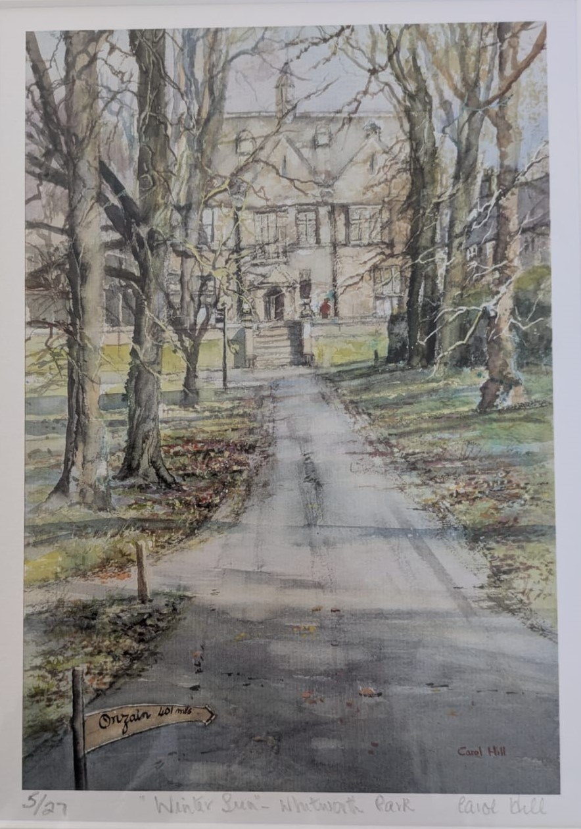

“Winter sun – Whitworth Park” an original painting by Carol Hill, commissioned by Darley Dale and District/ Onzain Twinning committee for the occasion of our visit to Onzain in May 2026.

Dates for your Diary

- Visits to Onzain by The Fishpond Choir and Winster Morris 14-17 May 2026
- AGM – 24 June 2026 at 8:15pm – Darley Dale scout hut, Darley Churchtown
- 3-12 August – European solidarity project (Onzain – Hellbrun)
- 9 August Darley Dale brass band at Barringtons
- Darley Dale scouts summer Fayre and hog roast– 15 August
- Language café – resuming September 2026

Celebrating achievements
- This is our fourth newsletter and we hope you are enjoying the more regular updates on what we are doing.
- In the last newsletter, we introduced a new feature focussing on individuals and businesses in Darley Dale who contribute to the community. We hope this is of interest to both our readers in Darley Dale, as well as those looking at us from the Loire. Unfortunately there are no similar videos or profiles this month, but we will endeavour to resume the feature in our next Newsletter. If you would like us to feature your business, contact David Gray at d.gray811@btinternet.com

Opportunities
- We continue to work with Alfie Flint of Brother Hub (based in Darley Dale) to develop an interactive Treasure Quest challenge.
- We are considering the possibility of organising either a walking trail around Darley Dale or a car based Treasure Hunt around the surrounding area over the summer months. Interested?
- We are still looking for help to revamp our website and social media platforms. If you could help, please get in touch.
- We are always growing our membership base. Please forward this newsletter to friends and neighbours and ask them to get in touch with Nadine nadinesnowsill@gmail.com so we can add their details to our data base. There is no commitment by signing up, and you can always ask to leave at any time!

Valentine’s Day Prize Draw

Our Valentine’s Day themed prize draw was a great success. The winner of the case of mixed, premium wine was Angela Hadfield after her ticket was drawn out of the hat by mayor, Councillor Jason Farmer.

With almost all the 200 tickets sold, the Twinning group’s chairman, David Tidd, said how pleased he was with the success of the draw and over £500 surplus that would help our group with the funding of its projects.

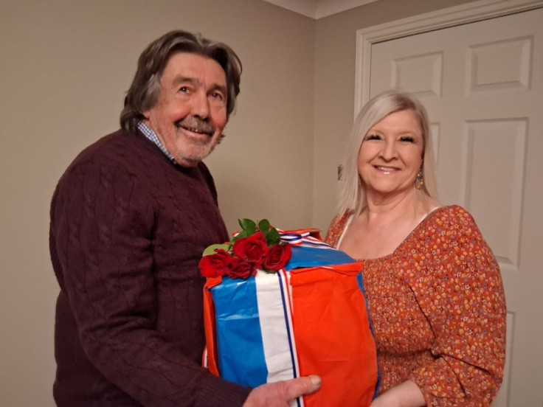

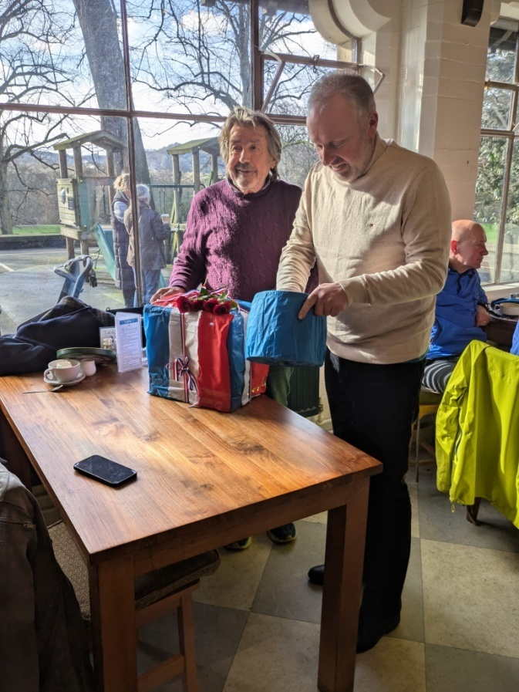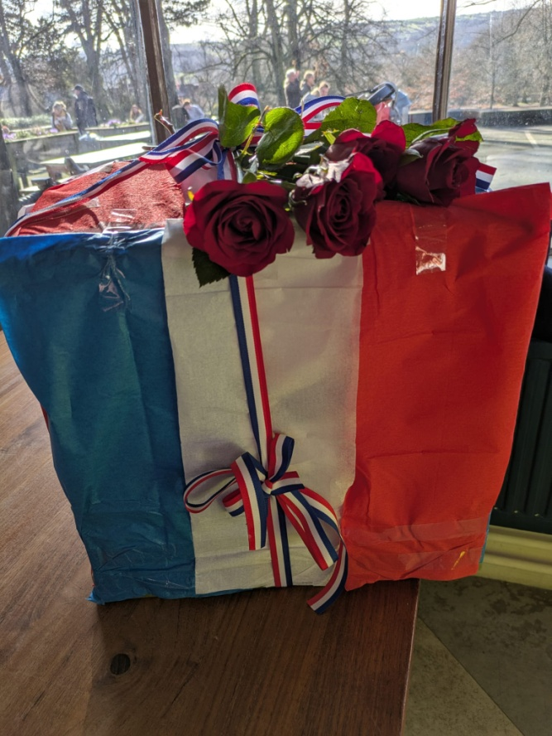

Whilst we are pleased with the funds that this prize draw generated for our reserves, this was almost entirely due to the active selling of tickets to those not directly associated to the Twinning group. It was especially notable that so few of those on our distribution data base actually purchased draw tickets. A lack of tangible support for this draw from those who appear most closely linked to the “twinning” movement in our community is noted. It has caused us to wonder if the distribution list accurately reflects people who still have an interest in what is happening within the “Twinning” group. Are there people receiving the information we circulate who are no longer interested and would perhaps prefer to have their details deleted? We would be very happy to do this so we do not trouble those who are no longer interested in our activities. Please contact Nadine nadine.snowsill@darleydaletwinning.org.uk to have your contact details deleted, if appropriate.

Update from the Loire

Changes to personnel involved with the Twinning movement in Onzain continue to be bought to our attention. In the last newsletter we announced that Valerie LHuillier has taken over from Pierre Bonneville as President of Onzain Jumelage (their twinning management committee). We have heard that Pierre has subsequently been voted to be one of the 3 commune mayors for the town of Veuzain-sur-Loire, so that should ensure there is ongoing support for twinning in the council chambers. The new overall mayor for the town is Yves Lecuir and we look forward to meeting him during our visit in May.

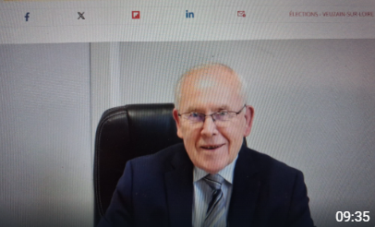
Yves Lecuir – the new mayor of Veuzain-sur-Loire, of which Onzain forms a large part.

Roulons avec les flames project

In August 2026 the Onzain Jumelage, in partnership with their other twinned town of Flein in Germany, are organising a solidarity event for young people from each of the 3 twinned towns, (including Darley Dale). The event starts with a 4-day cycle ride from Onzain to the town of Helbrun in Germany where 4 further days of activity, solidarity and relationship building will take place.

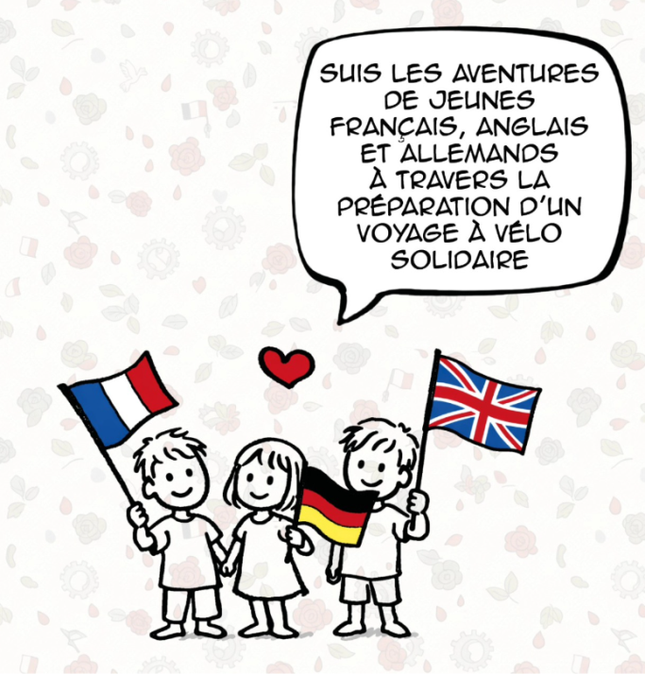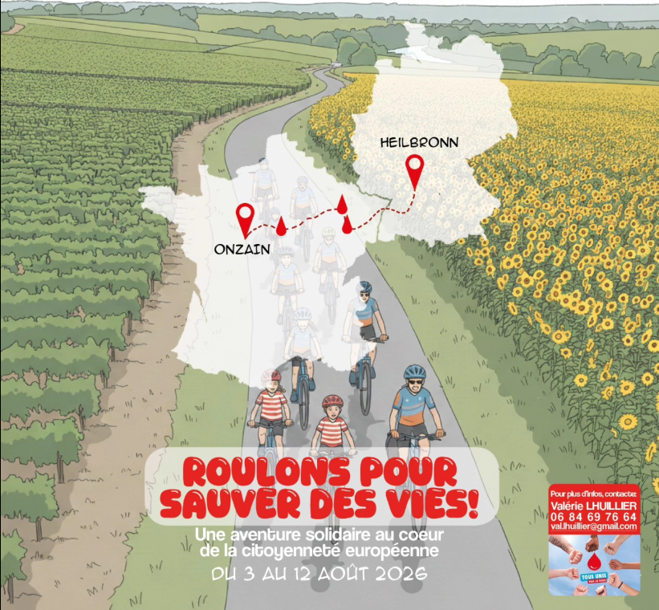
If successful it is expected that a similar event will be staged in Onzain in 2027 and Darley Dale in 2028. We have been unable to get anything but minimal participation in this year’s event from young people in Darley Dale. However, our efforts to draw attention to the event has identified a student who lives within the Derbyshire Dales and who has shown great enthusiasm to participate this year. Our committee has agreed to partly support him, with matched funding from the Town Council, on the basis he will provide us with the feedback to enable much stronger promotion (and hopefully participation) of the 2027 event.

Trip to Onzain in May 2026

Arrangements are now almost complete for the trip to Onzain over the weekend of 14-16 May 2026. The Fishpond Choir have been specifically invited to be part of a 3 way concert that will include choirs from Onzain, Darley Dale, and also Flein (a town in Germany, which is also twinned with Onzain). Winster Morris will enjoy their own invitation from the La Valiscienne dance group to be in Onzain over the same weekend. A total of some 62 people will be travelling to Onzain for this weekend, either on the specially chartered coach, or using their own transport arrangements. Many of those travelling will be staying with French hosts, some of whom have never met each other! It promises to be a very memorable few days when old friendships will be rekindled and new ones undoubtedly formed. We will have a full report in our next newsletter.

Winter sun – Whitworth Park
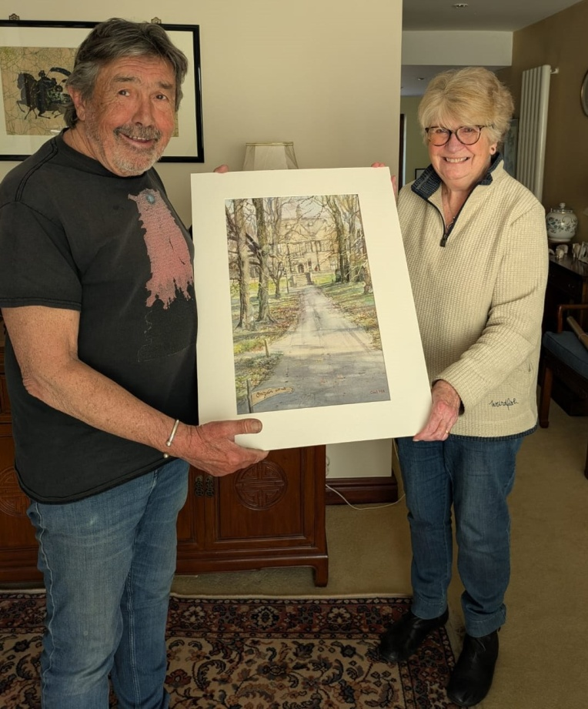

Local artist, Carol Hill has just completed a new painting, showcasing one of the iconic views of Darley Dale looking through the trees in the park, up to the Whitworth building. Carol was commissioned by the Darley Dale/ Onzain Twinning group to paint a view of Darley Dale that would be suitable for using as a gift for the French people hosting the visit to Onzain in May. Carol has very generously donated the original painting as a gift to be presented to the former president of the Onzain Jumelage committee, whilst a framed copy will be given to the new mayor as a gift from Darley Dale Town Council to commemorate the ongoing Twinning links Darley Dale has with Onzain. The presentation will be made by our own mayor, Councillor Justin Farmer who will be a member of the visiting party. Others who are staying with French families will be giving signed limited edition prints of the picture to individual hosts as a gift of their stay.

Carol is an accomplished local artist who has lived in Darley Dale for over 11 years, and in the district for over 30. She is a full member of both the Society of Women Artists and the Royal Birmingham Society of Artists. She has regularly exhibited at the Mall Galleries in London and in 2009 was awarded the HRH Princess Michael of Kent watercolour award for the most outstanding watercolour in the SWA exhibition. In 2017 she was awarded the Harris Moore Canvas prize at the RBSA prize exhibition. She is currently president of the Matlock Artists Society. As well as her own paintings (mainly watercolour and oils) she is also a qualified adult education teacher organising workshops, demonstrations, etc to art groups across Europe, UK and Australia.

Carol regularly uses her walks around Darley Dale as an inspiration for her paintings. She often walks in Whitworth Park and loves the different views that it offers. Having agreed to paint something for the Darley Dale Twinning group's visit to Onzain she had no doubt that a view of the unmistakable Whitworth building, through the parkland in winter sunshine would make the perfect picture and an ideal, unique gift for our hosts. A lack of sunny days in this year's wet winter meant a slow start to the preparatory work but eventually the weather was right to catch the glow of unfamiliar rays on the building's stones. The inclusion of the milepost is a feature borrowed from the newly created Onzain garden under artistic licence, but it provides the perfect link to the twinning visit to be made in May 2026.

Annual General Meeting

We are adopting a new format for this year’s AGM on Wednesday 24 June. . One of the priorities in our 5-year plan is to have greater engagement with young people and Darley Dale Scout group have already shown, on several occasions, they are keen to work with us. Accordingly we will start the evening of our AGM engaging with the scouts through various activities. We will also be making delicious pizzas in wood-fired ovens that we can share with everyone who comes along. The formal part of the meeting will be held at the scout hut in Darley Churchtown at 8:15pm. Please come along to hear what we have achieved in 2025-26 and how our plans are being refined to achieve priorities. This is your chance to have your say, share your ideas, or just get an idea about what the many things being involved in Twinning can mean. For more information please contact our Secretary, Nadine nadine.snowsill@darleydaletwinning.org.uk for more details.

Engagement with schools and young people

As we have reported in previous newsletters, the committee has been making significant efforts over the last year to engage with all junior and senior schools serving the community of Darley Dale. We have had face to face discussions with head teachers and other senior members of staff who are in positions to direct pupils towards possible activities linked, directly or indirectly, to “twinning”. We have also made strong links with senior and primary school teachers in the Onzain area who have stated very enthusiastically their desire to set up direct links with English speaking pupils. Yet, despite the positive comments made to us at meetings with local teachers, none of the proposed ideas to link young people in the two communities have yet been taken forward. We will continue to try and establish how we can develop the links.

Meet the People in Our Community

This was a new feature in the last newsletter. In future newsletters we will resume focussing on some of the people who live, work and relax in Darley Dale by using a short video interview with them.

Wirksworth Twinning Group

Between 2 and 6 July 2026 Wirksworth Twinning group are hosting 46 visitors, with 20 coming from Die and 26 from Frankenau. There will be 25 families hosting the visitors and a full programme of events has been arranged for them. Anyone wishing to know more about the exchange visit, or even wish to get involved as a volunteer should contact fberryman@talktalk.net.

We hear that some of you are interested in watching good quality foreign films and so we are helping to promote the programme that our friends in the Wirksworth Twinning Group are showing at the Northern Lights cinema in Wirksworth each month.

Their next film is Colours of Time on Monday 1 (8:00pm) and Tuesday 2 June 2026 (5:30pm). It is a French film with English sub-titles. The film follows four cousins who inherit a house in rural Normandy and retraces the steps of their ancestors in 19th-century Paris.
The Twinning group provide pre-film nibbles for the Tuesday showing for those who want to meet beforehand.

Any feedback on this newsletter, or queries relating to the work of the Darley Dale Twinning Group may be sent to D.gray811@btinternet.com

