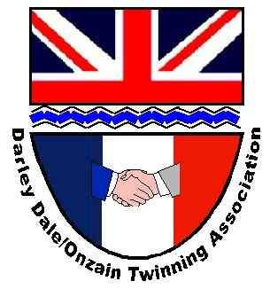
From the Derwent to the Loire
The newsletter of the Darley Dale and Onzain Twinning committee - October 2026

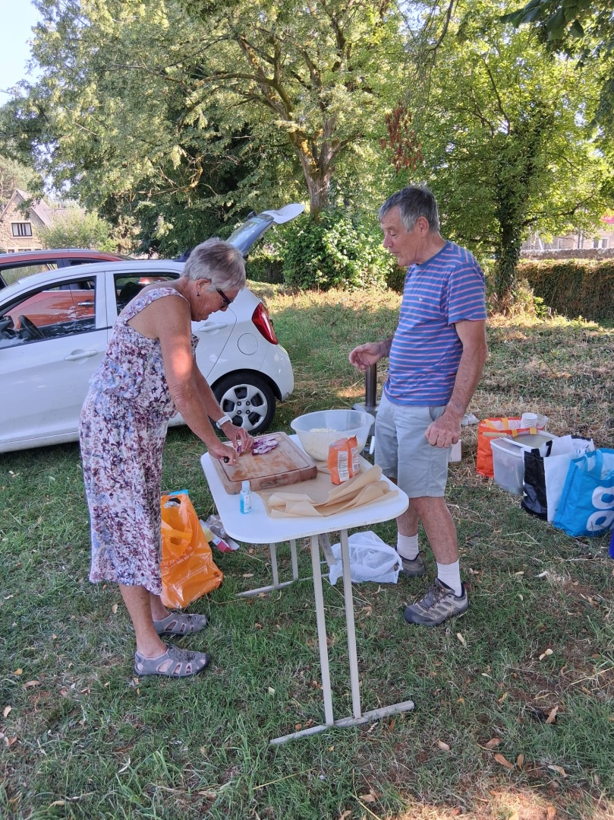
Treasurer David Gray and Deputy Chair, Linda Tidd, hard at work preparing pizzas for the hungry Darley Dale cub pack in June

A big welcome to anyone who is reading our newsletter for the first time.

Celebrating Achievements

- It’s been quite a busy summer and members of the committee have been working hard to try and increase the profile of Twinning within the Darley Dale community
- Our pizza night with Darley Dale cubs was very well received, with the pizzas rated as being better than Dominoes!!
- We held, what we beleive was Darley Dale Twinning’s first open-air AGM in June
- We had our own stall at the Darley Dale Scouts’ Family Fun Day with Hog Roast in July.
- Our Treasurer made a personal visit to Onzain in September but, even though it was not a formal twinning event, he and his wife were very warmly received by the Jumelage committee.

Opportunities

- We are still considering the possibility of organising a new fund-raising walking trail around Darley Dale. We will use the car based Treasure Hunt which Nadine has prepared when we next have visitors from Onzain, but anyone wishing to use it should contact Nadine
- We are still looking for help to revamp our website and social media platforms. We may have somebody to lead with this project but if you could help, please get in touch.
- We are always trying to grow our membership base. Please forward this newsletter to friends and neighbours and ask them to get in touch with Nadine nadinesnowsill@gmail.com so we can add their details to our data base. There is no commitment by signing up, and you can always ask to leave at any time!

Update from the Loire

We are able to provide you with a very personal update from the Loire in this Newsletter as our Treasurer, David Gray and his wife Jenny, called in to pay a visit to Onzain on their way home from a cycling holiday in the south of France. David says….

“From the moment we stepped off the train at Onzain station with our bikes we were warmly welcomed, entertained, and extremely well looked after by many members of the Onzain Jumelage team.

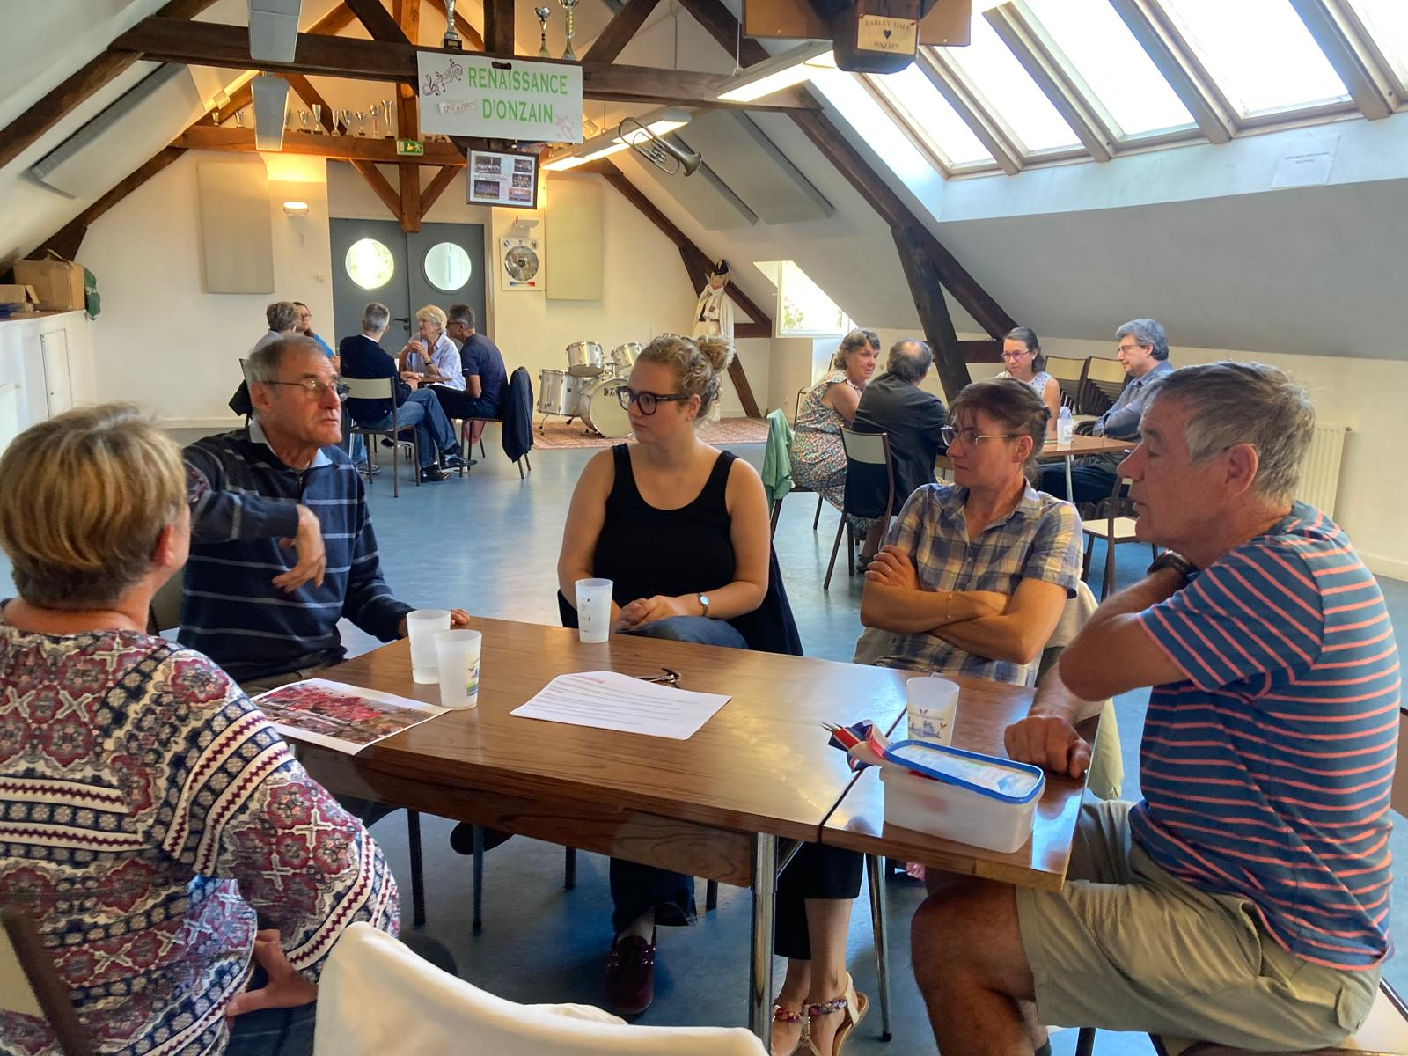
David contributing to the lively small group discussions at the Café de Langues on Saturday morning.

Although this was not a formal exchange visit, it was too good an opportunity to miss for sharing thoughts on issues that we are thinking about on both sides of the channel. On a lovely, sunny evening we sat outside and talked at some length about a possible scout visit to Onzain in 2028, the potential for special celebrations to mark the 40th anniversary of the twinning agreement in 2029 and the format for other possible visits in 2027.
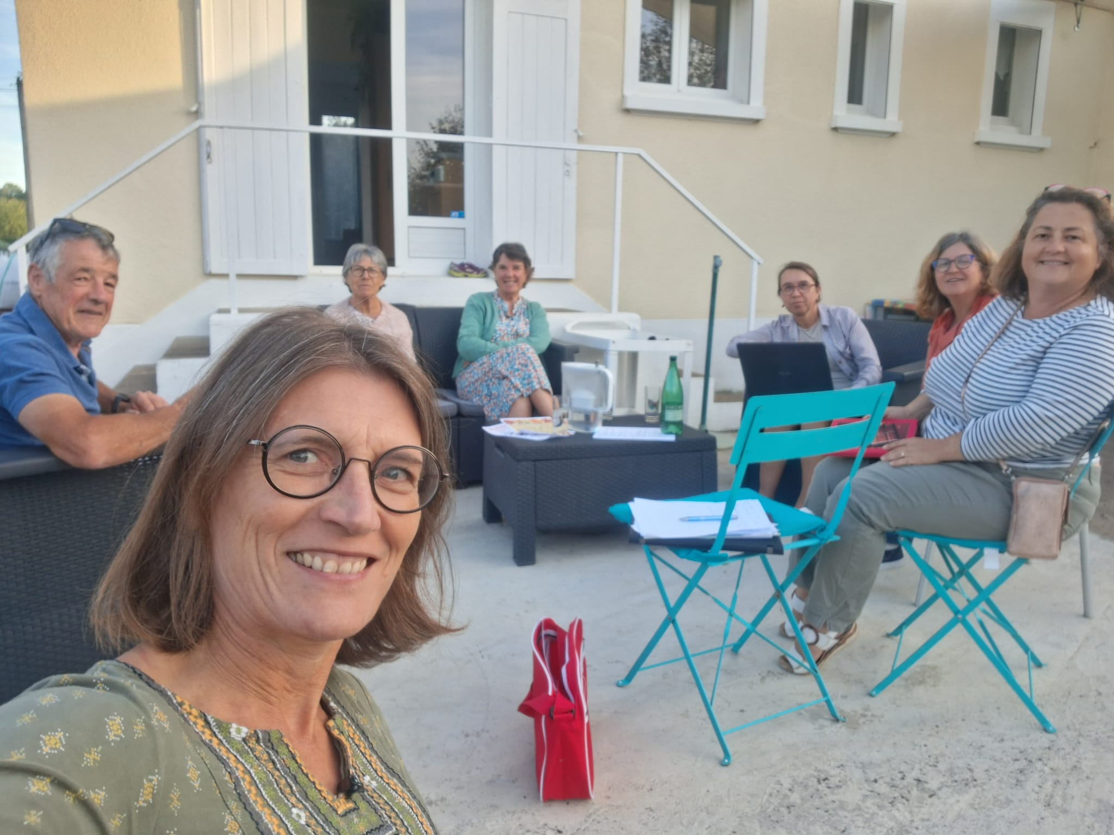
An informal, bi-nation, outdoor committee meeting

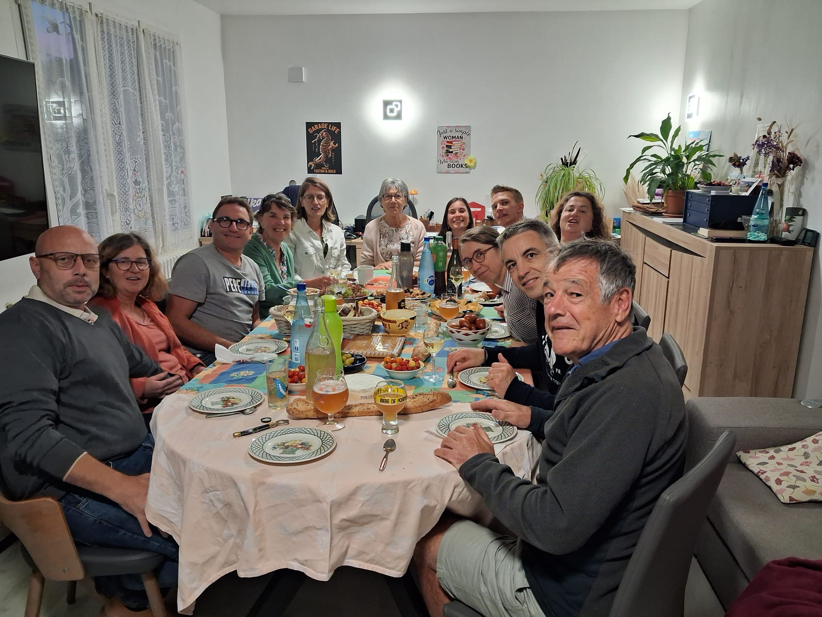
Meeting finished, let’s party!

With the meeting finished we moved indoors to where a wonderful feast had appeared, as if from nowhere. It was such a lovely, convivial atmosphere, and we were made most welcome by everyone. For the rest of our stay we had a relaxed time visiting the local goat cheese farm shop, as well as the wine cave where so many others from Darley Dale will have visited over the years. Finally a guided tour of Les Douves, a lovely restored Chateau in the heart of Onzain, which is only open to the public at occasional times each year.
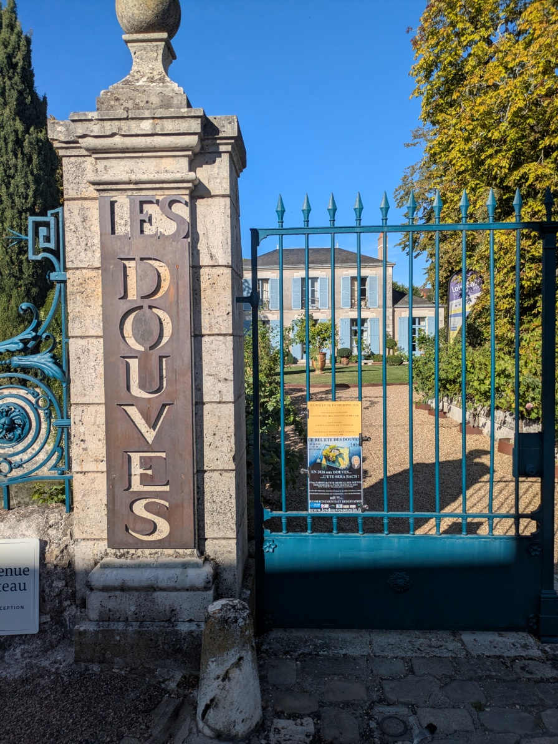
The Back to Bach concert at Les Douves in the evening was great fun, but not quite what we had expected!

We left early after breakfast on Sunday morning, laden with many gifts, both from Eve and Dany’s garden as well as their own cellar. Our stay was a truly memorable end to our holiday but also a very strong endorsement of the links we feel we have with Onzain and the ever closer friendships with members of the Jumelage committee”.

Roulons avec les flames project

This tri-nation event for young people took place, as planned, in August 2026. Starting in Onzain, a group of mixed age teenagers and adult guides set out to cycle over 4 days to Flein in Germany – a town that Onzain is twinned with, as well as being twinned with Darley Dale. The group included Patrick Hall, a local Derbyshire student who was the sole representative in the group from the Darley Dale area.
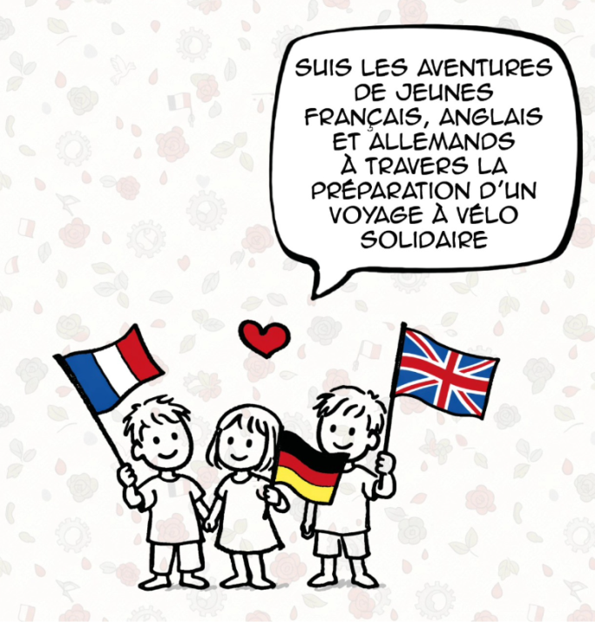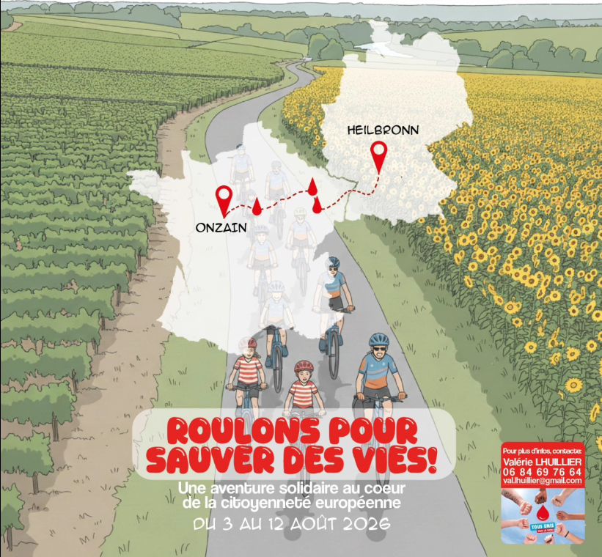
Once the riders arrived in Flein, they spent a weekend of tours, visits and other leisure activities with teenagers from the local area. In total it was 8 days of great fun for everyone involved. Apart from the obvious benefits for young people of developing new contacts and friendships, the project had specific ambitions to promote the importance of blood donations across all nations. Wherever the travelling group stopped during the day, as well as overnight places, they undertook a range of diverse activities to promote the need for more donors. The young people demonstrated incredible and varied talents to get interest in the appeals from the general public. Through these moments, as well as exposure on local radio, social media etc the organisers estimated that potentially 100,000 people heard their messages. The target of getting 100 promises for new donors was well exceeded. Overall, the French Jumelage committee organising this event were really pleased with how it all went.

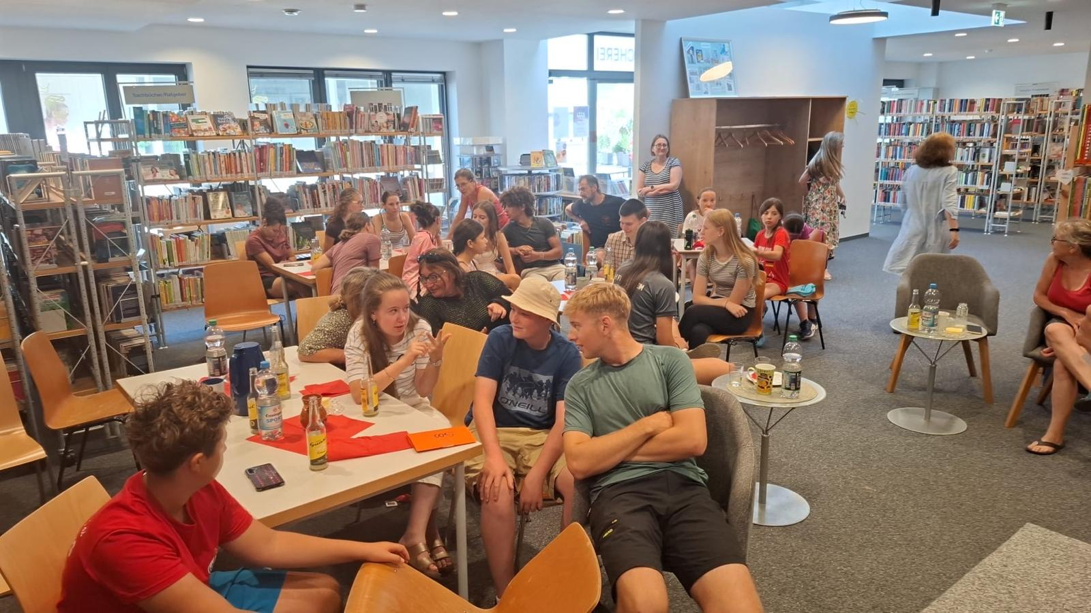
One of the morning briefing sessions (Patrick in green shirt at front)

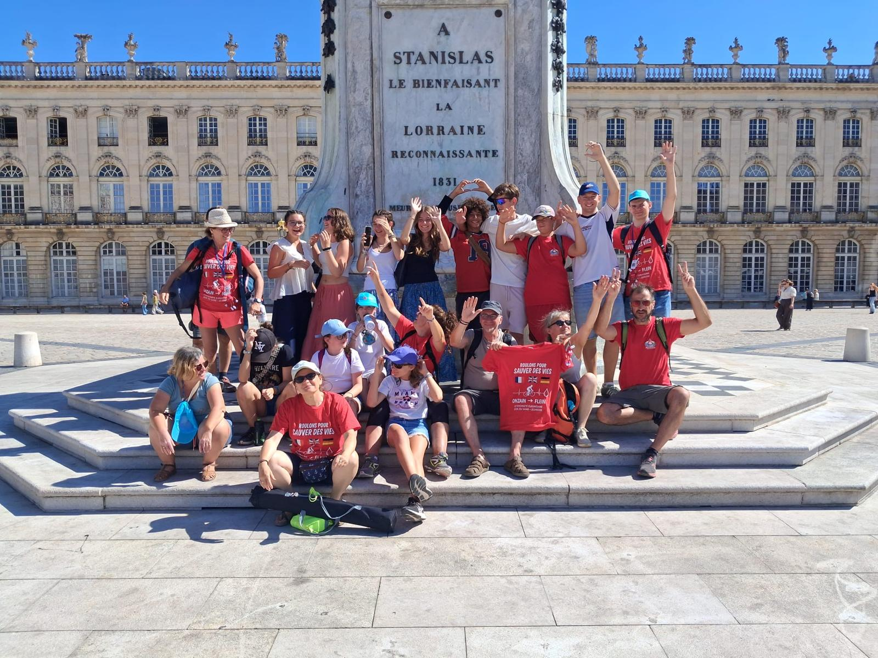
One of many group photos

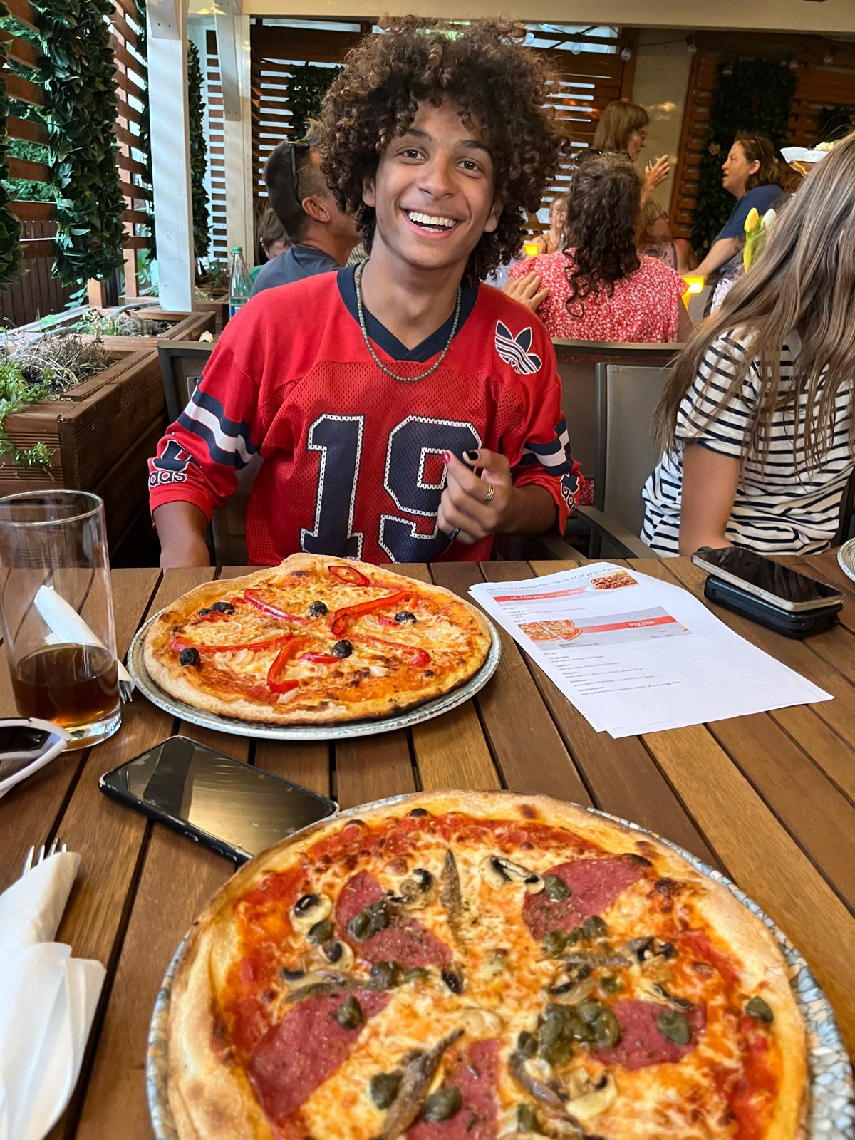
One of the young people from Onzain at dinner time

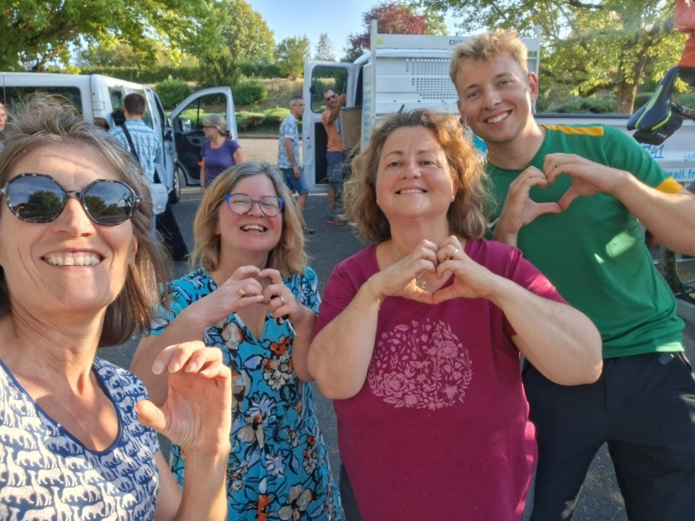
Patrick (far right) with members of the organising committee

Patrick has now fed back on how he found the event, and has given it an over-whelming thumbs up. Watch his own summary of the event in his video, which is now on our website. With funding provided from our own funds, matched by that provided by the Town Council, we were able to ensure his own costs were kept to an absolute minimum. We are looking forward to hearing from the Jumelage Committee in Onzain what format the event will take in 2027, and we can then start to work out how we can get more participants involved. If you might be interested in taking part, please get in touch with Darley Dale Twinning.

Annual General Meeting
This year’s AGM was held on Wednesday 24 June and for the first time, we think, it took place as an open air event at the scout hut in the wonderful summer sunshine.

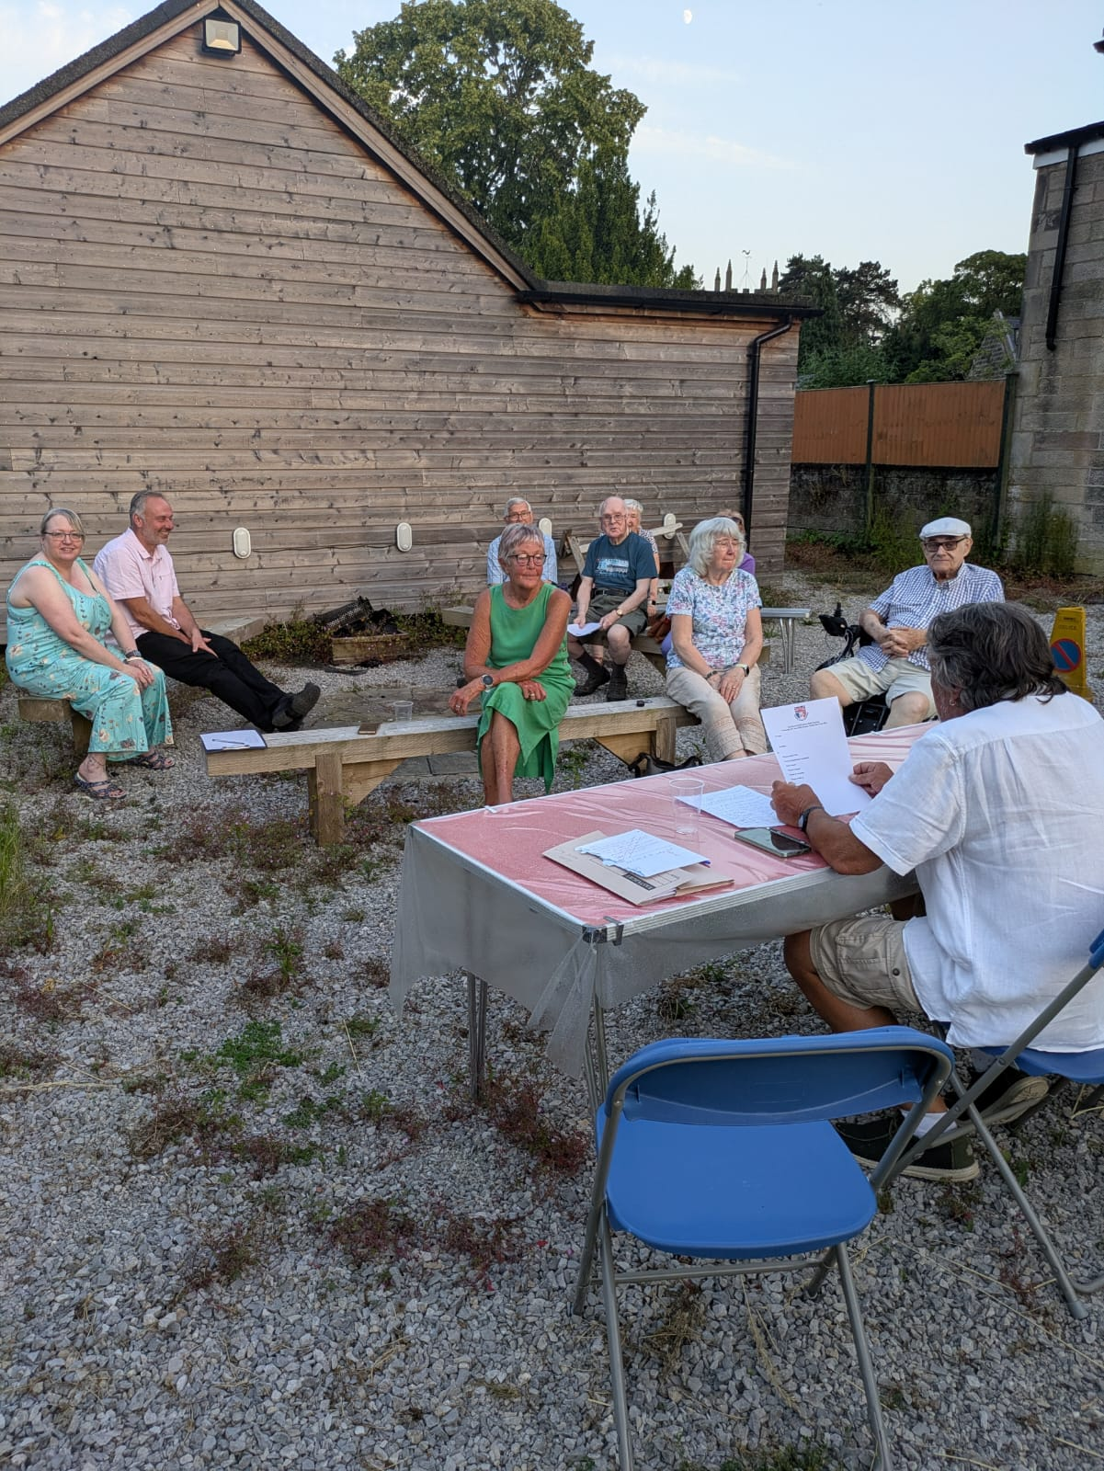

Turnout was disappointingly low. However it was very nice to have a couple of long time supporters come along, despite living in Sheffield now. It was also a great boost for the committee that Mayor Jason Farmer was there to provide his support from the Town Council. Our Chairman, David Tidd gave a full recap on the committee’s activities over the past year and applauded the achievements that such a small team were able to list. However, he recognised that the profile of twinning within the Darley Dale community is still not as great as we would like it to be despite our efforts to improve this. New approaches will need to be considered for 2026-27.

Pizza night with the cubs and scouts’ gala day

On a beautiful summer’s evening in early July, members of the committee turned their hands to making pizzas for the Darley Dale cub pack in wood-fired pizza ovens. Local scout leaders are keen to increase the involvement of younger people in Twinning, and in making connections with the community in Onzain. Whilst pizzas are perhaps not traditionally considered to be French food, we were able to involve the youngsters in many games and activities which kept them busy, and had a bit of a French or European flavour. Each cub had the opportunity to design their own pizza toppings and decide when the bases were cooked to their own personal liking. The feedback was unreservedly positive

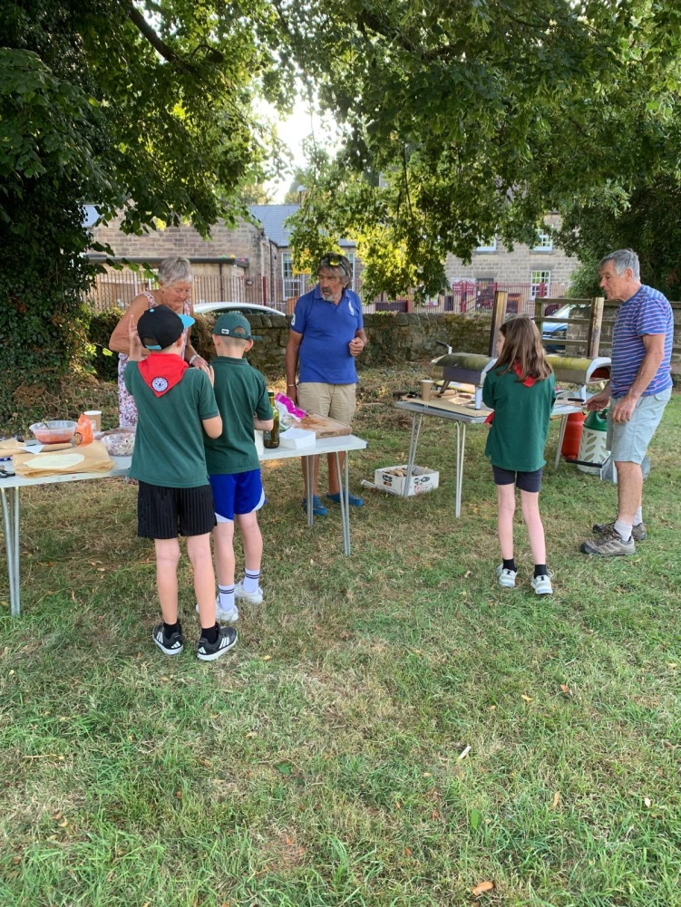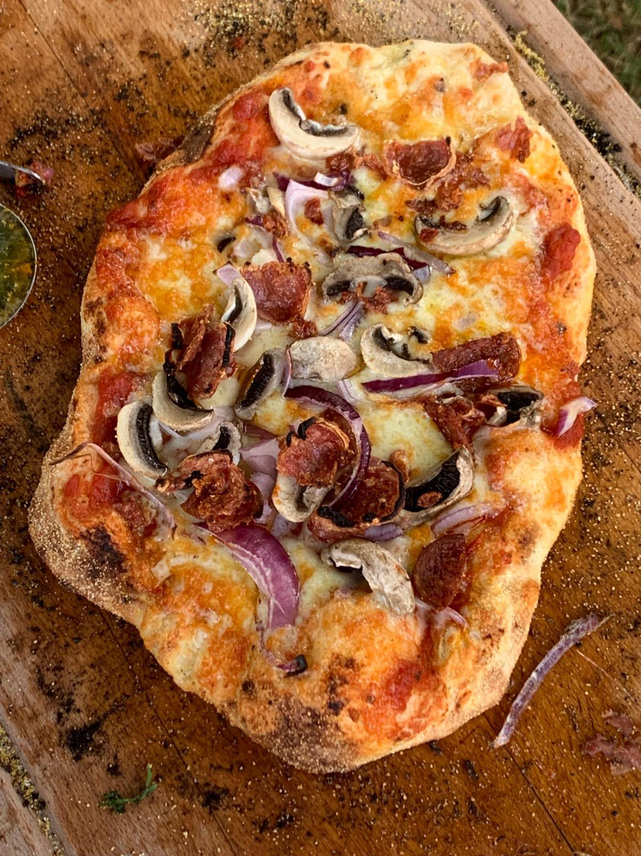
On orderly queue to design the pizzas, but what an outcome. Better than Domino’s, apparently!

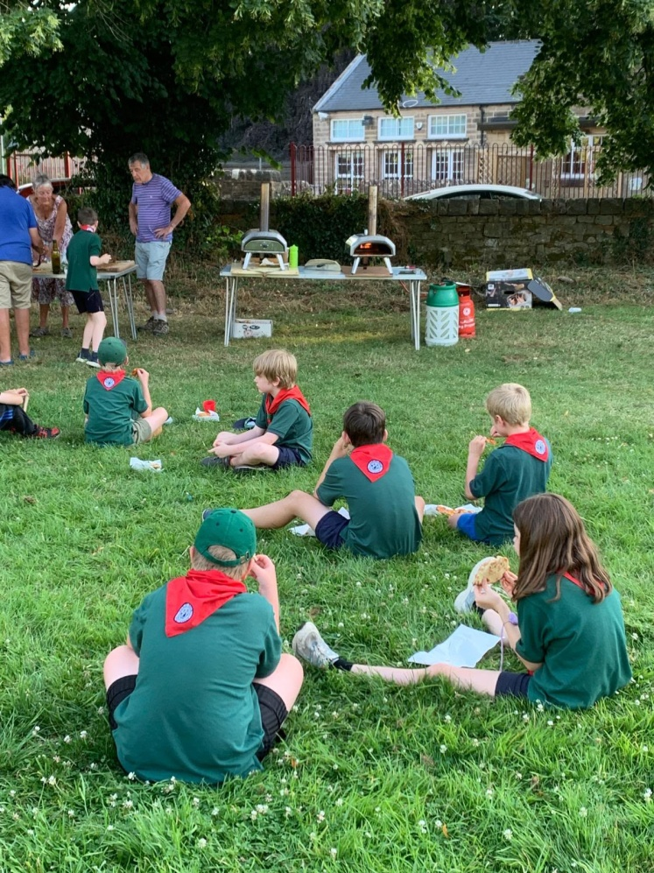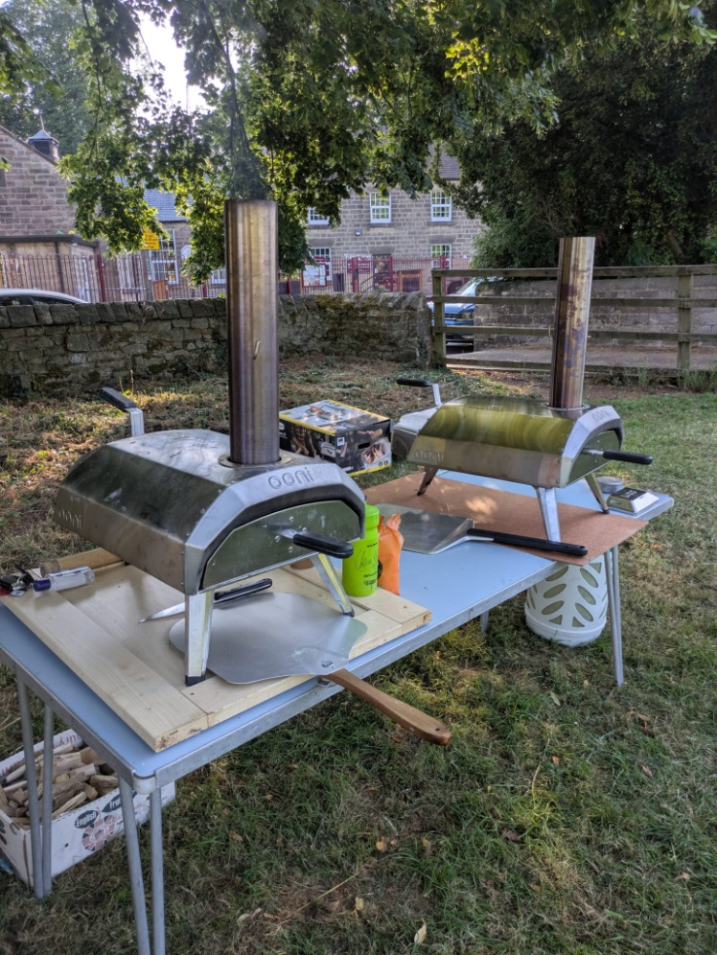
Pizza picnic and the production line

Later in the summer we were invited to promote Twinning at the Scouts’ Family Fun day and hog roast. As well as some fund-raising with a raffle, we also had a second hand “blind-date with a book” stall (books wrapped up so you bought “blind”, other than with help of brief narrative as to what they were about!). The French and European jigsaws were as popular as always, and we enjoyed talking to a few people who were interested in hearing about Twinning. We added a few more names to our circulation list, so a worthwhile afternoon.

Future exchange visits
The committee is currently looking at options for future exchange visits. We are conscious that 2029 marks the 40th anniversary of our Twinning Association with Onzain and we would like to ensure it is suitably marked in some way. However, it is a decision the Town Council will probably want to be involved with, and so we are keen that their representative attends our regular meetings.

There is the possibility that another cycling event for youngsters will take place in Onzain in 2027 and we will certainly be trying to get greater participation. The format may be slightly different based on lessons learned from this year. The other organising towns from France and Germany expect us to host the event in 2028!

Darley Dale scouts are contemplating their own, independent visit to Onzain in August 2028 and we are working with the Jumelage committee to try and facilitate this.

We would love to encourage a visit(s) to Darley Dale by wider or individual groups within the Onzain community. David’s discussions with the Jumelage committee on his recent visit highlighted the possibility that any trips in either direction could be of a smaller scale than have been the norm in more recent years. There may still be a demand for a larger scale visit to Darley Dale, but we are also going to look at how smaller groups could be encouraged to visit separately, especially if hosted by organisations locally.

Anyone who has thoughts about possible exchanges (to/ from Onzain) in the next few years would be very welcome to share them with us.

News from Wirksworth Twinning Group
In July 2026 the Wirksworth Twinning group hosting 46 visitors, with 20 coming from Die and 26 from Frankenau. The visit was a great success and, although we weren’t actively involved, we are very pleased that other local Twinning groups have received such excellent support from their local communities. A return visit to Frankenau is being planned for May next year.
The dynamic nature of their group is very encouraging, and we have been developing closer links with the Wirksworth team to see how we might improve our own plans and ideas for Twinning in Darley Dale.
Wirksworth have regular monthly foreign film nights at the Northern cinema in Wirksworth. Details of their next film are attached at the end of this newsletter. They are well supported so, if you are interested in going, booking in advance might be appropriate.

Christmas 200 raffle
You may recall we held a 200 ticket raffle for Valentine’s Day earlier this year. It was very successful and raised important funds to support some of our subsequent activities this year. With the possibility of funding being required for 2027 visits, we need to start building up our funds. The raffle will once again be restricted to the sale of just 200 tickets at £5 each, with the prize being a full case of premium wine. The draw will take place before Christmas making it the best start possible to the festive period.

We will let you know as soon as the tickets are printed and how you can get hold of them. Please do support this event as generously as you possibly can. We don’t currently look for membership fees or subscriptions to be a part of the twinning group so, we are hoping those who are interested in our activities will support us with events like this. Thank you.

The ongoing survival of Twinning in Darley Dale
For many years we have co-ordinated the payment of public liability insurance premiums with nearby fellow twinning organisations at Ripley, Matlock and Wirksworth. This has kept the level of our own premiums lower than they would otherwise be. A couple of years ago the demise of the Matlock Twinning group meant we were down to just 3 partaking organisations. We have just received this message from the Ripley group which will mean that only ourselves and Wirksworth are left from the original group.

“It is with great sadness that I have to inform you that the Ripley & District Twinning Association at a 'Special General Meeting' on Tuesday 22nd September 2026, the Members' decided to dissolve the Twinning Association with immediate affect. The reason is that some of my Members' have health and mobility issues and are unable to carry on with the exchange visits etc. and as with most voluntary organizations, we have no younger Members' joining to take over the running of the Association.”

This is very sad news and echoes some of the concerns we have about the underlying strength of our own organisation here in Darley Dale. We strongly believe there are many people living in Darley Dale who are not aware that Darley Dale is twinned with Onzain, nor what that actually means in practice anyway. When asked, many people cannot recall the information on signs on all roads leading into Darley Dale, which indicate the nature of our twinning links. If the future of twinning is to be assured then we must increase the awareness of twinning, and try to engage more people and groups withinin it. Twinning has survived almost 40 years in Darley Dale, but if it is to survive 40 more we need more people involved, either helping to run the organisation, actively supporting our campaigns, fundraising for activities, hosting visiting persons from Onzain, or otherwise being actively involved with the principles of twinning.

We are looking at the imminent possibility of having QR codes located widely across the town, which can be scanned by anyone to give more information immediately about the nature of twinning arrangements in place between Darley Dale and Onzain. This should be helpful and a useful development. However, on its own it is unlikely to bring about the scale of involvement we are hoping for. Perhaps what people really want to know is how twinning can provide them with benefits or opportunities. Perhaps they can’t visualise how contact with people in some far away town in another country helps improve the environment they live and work in, here in Darley Dale. These are the sorts of questions we need to be able to answer clearly for them.

To help us address these questions we need people to join the committee who have experience of past twinning involvement and can convey their enthusiasm to others, but we also need those with no prior experience but who have specialist skills which might help us improve our profile through social media, French speakers, those with experience of working with young people groups, fund-raisers, etc. If you have any thoughts on how we can improve our profile but don’t want to, or can’t commit to joining the committee please just pass them on to us. Everyones’ thoughts are useful.
Any feedback on this newsletter, or queries relating to the work of the Darley Dale Twinning Group may be sent to d.gray811@btinternet.com

Wirksworth Foreign Film Night (see below)
